|  |  |  |  |
| --- | --- | --- | --- |
|  | | ***Reference:***  *SUCE-GISAT-ES*  ***Issue:***  *1 – 29/03/2017*    ***Revision:***  ***Distribution Code:***  *Restricted Distribution* | |
|  | | | |
|  | | | |
| **SUCE** | | | |
| SUCE Executive Summary | | | |
|  | | | |
|  | | | |
| (ES-v1.0) | | | |
|  | | | |
|  |  | |  |
|  |  | | ***Prepared by:***  *Marketa Jindrova*  *28/03/2017* |
|  |  | | ***Verified by:***  *Ondrej Nalevka*  *29/03/2017* |
|  |  | | ***Approved by:***  *Ondrej Nalevka*  *29/03/2017* |

|  |  |  |  |
| --- | --- | --- | --- |
|  | | | |
| ***Contract*** | |  | |
| *Contractual* | : | | ✓ |
| *Contract issuer* | : | |  |
| *Contract n°* | : | | ESRIN/Contract No. 400112833/14/CS SUCE |

|  |  |  |  |
| --- | --- | --- | --- |
|  | | | |
| ***Classification*** | |  | |
| *General Public* | : | |  |
| *Industry Programme* | : | | ✓ |
| *Restricted Dispatching Programme* | : | |  |
| *Confidential Programme* | : | |  |

|  |  |  |  |
| --- | --- | --- | --- |
|  | | | |
| ***Configuration*** | |  | |
| *Configured document* | : | | ✓ |
| *Non-configured document* | : | |  |

|  |  |  |  |
| --- | --- | --- | --- |
|  | | | |
| ***References*** | |  | |
| *Reference* | : | | SUCE-GISAT-ES |
| *Issue* | : | | 1 – 29/03/2017 |
| *Revision* | : | |  |

|  |  |  |  |  |  |
| --- | --- | --- | --- | --- | --- |
|  | | | | | |
| ***Distribution*** |  | | | | |
|  |  |  |  | |  |
| *Name* | *Dept.* | *Copies* | *Information* | *Action* | *Comments* |
| Philippe Mougnaud | ESA | 1 |  |  |  |
| Andrea Della Vecchia | ESA | 1 |  |  |  |
| Pier Giorgio Marchetti | ESA | 1 |  |  |  |
| Michele Iapaolo | ESA | 1 |  |  |  |

|  |  |  |  |
| --- | --- | --- | --- |
|  | | | |
| ***Document Change Log*** | |  | |
| *Issue* | *Issue Date* | *Sections / Chapters Affected* | *Relevant Information* |
| 1.0 | 29/03/17 | all | Original |

**TABLE OF CONTENTS**

REFERENCE DOCUMENTS 5

1. INTRODUCTION 6

1.1 CONTEXT 7

1.2 OBJECTIVES 7

2. RESULTS 8

2.1 SUCE USE CASES & MAPPING SCENARIOS 8

2.2 SUCE DESIGN 10

2.3 Results evaluation 12

3. RECOMMENDATIONS & CONCLUSIONS 14

**LIST OF FIGURES**

Figure 1: Demonstration of different cloud cover distribution (grey colour) over a scene. 7

Figure 2: Left: list of scenes complying the user criteria; Middle: optimal coverage created from scenes available, random colouring chosen to distinguish between scenes from different dates, labels can be paired with products identifiers; Right: resulting image mosaic. 8

Figure 3: SUCE high level architecture. 11

**LIST OF TABLES**

Table 1: Data volume estimation for different areas and various satellites/ sensors. 6

Table 2: Overview of SUCE use cases and mapping scenarios, and their descriptions and output results. 8

# REFERENCE DOCUMENTS

|  |  |  |
| --- | --- | --- |
| # | APPLICABLE DOCUMENT | ISSUE, DATE |
| [AD01] | EO Product Metadata (Technical Note) | 07/03/2016 |
| [AD02] | Requirements Baseline (RB) | 11/12/2015 |
| [AD03] | System Requirements Specification & Software Design Document | 07/03/2016 |
| [AD04] | Use Case and Scenarios (Technical Note) | 22/10/2015 |
| [AD05] | Evaluation report | 09/09/2016 |

# 1. INTRODUCTION

With more Earth Observation (EO) satellite data available every single day and especially in the view of the coming Sentinel missions it becomes considerably challenging for the user to manage, search for and work with data required due to a huge volume of data and its size. Table 1 gives an overview of several satellites and their combinations with an average number of scenes per year and an average data volume in TB. For Europe there is also an estimate of the size of cloud cover (CC) information only (for all yearly scenes) which is significantly smaller than the data itself. Considering Sentinel-2A, Sentinel-2B and Landsat data the metadata (all that is needed for SUCE process) represents only 0.013 % of the total data volume. This demonstrates both an opportunity for a significant decrease in data transfer and for a decrease in computational demands on image archives (thanks to the fact that only desired EO products are downloaded).

Table 1: Data volume estimation for different areas and various satellites/ sensors.

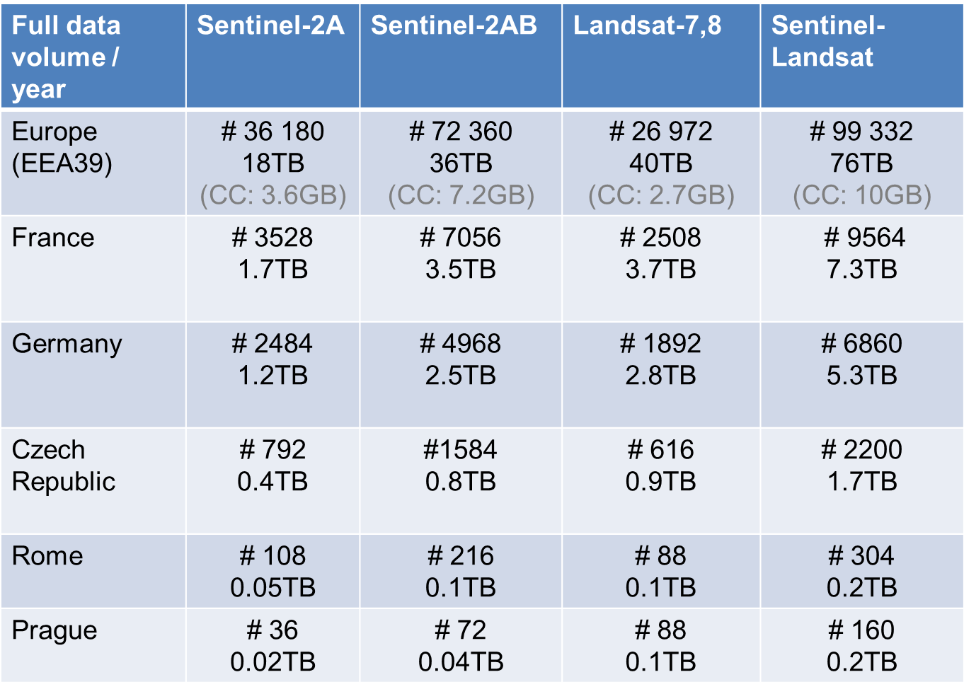

PDGS infrastructure shall be able to provide easy and powerful data search and data access capabilities, permitting to cope with a very large amount of data and to give users the possibility to take an advantage of dense temporal and large spatial coverage.

The most significant limitation of any optical data is the cloud cover which in the worst case can result in data being completely useless. There are many different data catalogues providing user with the ability to search through available data by date, area of interest (AOI), satellite/ sensor etc. Some of those catalogues provide the option of filtering the data by cloud cover as cloud cover information is included as % per the whole scene. However, this is still not efficient enough because a basic % of cloud cover over a scene does not tell the user the most important fact which is the cloud cover distribution over a scene. On Figure 1 the scene on the left is covered by clouds from 40 %, cloud cover of the scene on the right is 45 %. The cloud cover on the left scene is concentrated in the left part of the imagery which makes the right part of the scene well usable and nearly cloud-free. However, the cloud cover of the right scene is distributed over the whole scene which makes the whole scene useless for most of the analyses.

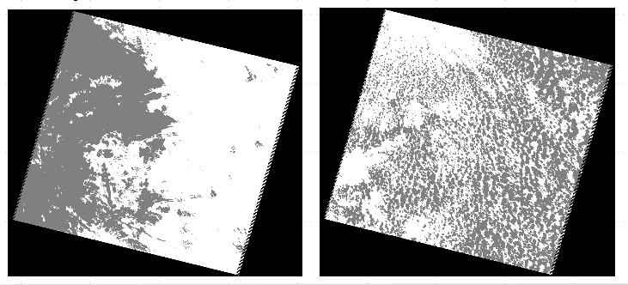

Figure 1: Demonstration of different cloud cover distribution (grey colour) over a scene.

Currently only ESA SciHub catalogue contains EO data including metadata information about cloud cover distribution which can be used by SUCE engine. More details about metadata have been provided in the EO Product Metadata- Technical Note document [AD01].

## 1.1 CONTEXT

Users from industry or scientific community usually request EO data through a number of various catalogues. After setting the data requirements (e.g. AOI, acquisition date, satellite/ sensor, % cloud cover, etc.) the results are returned via the catalogue interface containing metadata and links for downloading the whole products/ scenes from the image archive. When selected scenes are downloaded user usually has to derive cloud masks himself (if not already present) by using his own algorithms, and make a selection of suitable imagery manually by using spatial analysis. In case the resulted coverage is not satisfactory (e.g. gaps due to clouds/ shadows are still present, etc.) the whole process needs to be iterated until the coverage fulfils the defined mapping task conditions, whilst images not used are subsequently deleted. This results in an extensive manual effort, useless data transfer, and it requires large storage space and computational demand.

## 1.2 OBJECTIVES

The main objective of the SUCE project is to provide a prototype enabling to effectively select and download EO products from identified PDGS on the basis of advanced user criteria and analytic needs, and to define a concept and architecture of such a prototype. Through the analysis of EO products metadata, it shall be possible to derive optimal EO product sets suitable for user activities (e.g., Free Cloud Mosaic Composition of land-cover), avoiding both manual filtering and transfer of useless data.

SUCE tools aim at providing users with the ability to perform suitability analysis on archived datasets based on metadata, returning suitable results, displaying potential gaps in the coverage and using the metadata to provide links to download the datasets needed for defined mapping product from the archive(s). Particular requirements for SUCE prototype have been specified in the Requirement Baseline document [AD02] and in more technical way in System Requirements Specification document [AD03].

# 2. RESULTS

SUCE project designs a novel approach by which user can query (in an ideal case) any EO data catalogue. Based on a metadata query a fully automated process is performed by using an advanced algorithm which results in obtaining an optimal coverage. The approach developed within SUCE project is based on the availability of a cloud information. This information is represented by a cloud mask contained in the metadata, i.e. needs to be contained within HTTP link for corresponding scene, and so can be accessed and downloaded separately and independently of the whole imagery download.

An example of the process is given in Figure 2. User sets the criteria (AOI, time window, satellite, % cloud cover, etc.) and a list of available scenes is returned (on the left). An ideal coverage for selected AOI is created from those scenes where each scene is represented by a unique code and colour (for illustration part of the table listing the scenes is shown; middle) and a resulting image mosaic is shown on the right.

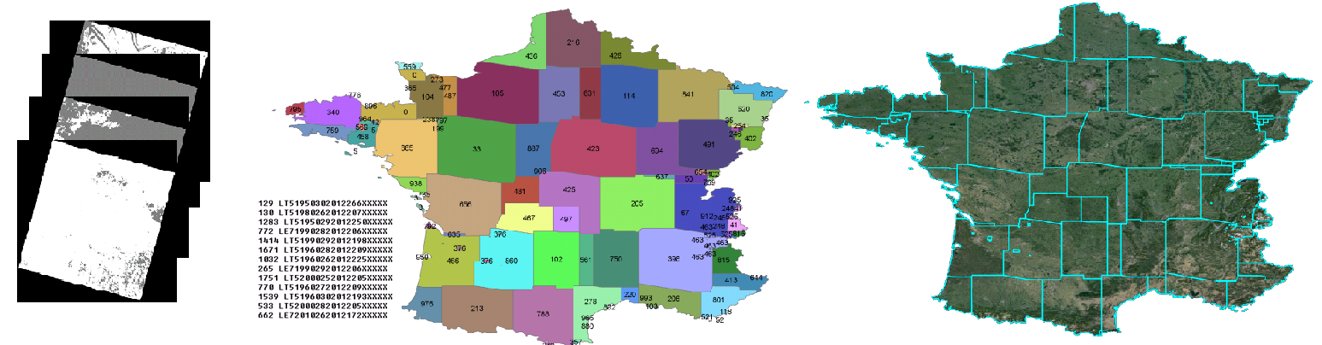

Figure 2: Left: list of scenes complying the user criteria; Middle: optimal coverage created from scenes available, random colouring chosen to distinguish between scenes from different dates, labels can be paired with product identifiers; Right: resulting image mosaic.

## 2.1 SUCE USE CASES & MAPPING SCENARIOS

Based on the most common user requirements and mapping activities (e.g. Continental land cover mapping, Regional mapping, Area frame sampling, and SAR snow mapping) four use cases were identified and are tackled by the SUCE system: Single scene, Temporal coverage, Spatial coverage, and SAR scenario (See Table 2). Particular use cases being addressed by SUCE are described more in detail in Use Cases and Scenarios Technical Note document [AD04].

Table 2: Overview of SUCE use cases and mapping scenarios, and their descriptions and output results.

|  |  |  |  |
| --- | --- | --- | --- |
| **USE CASE** | **MAPPING SCENARIO** | **DESCRIPTION** | **OUTPUT RESULT** |
| **Continental Land Cover Mapping** | **Temporal Coverage (time series)** | AOI of continental size (e.g. EU, EEA39). User interested in how many valid cloud-free observations there are.  This use case is addressing issues being identified within continental mapping (e.g. Corine Land Cover, other HRL mapping tasks) where ideally seamless cloud-free coverage with country-specific acquisition windows is required. | Raster map covering AOI where pixel value represents number of valid observations. |
| **Continental Land Cover Mapping** | **Spatial Coverage (seamless coverage)** | AOI of continental size (e.g. EU, EEA39). User wants to cover AOI by optimal EO coverage based on specific criteria (AOI, acquisition window, satellite, % cloud cover, etc.)  This use case is addressing issues being identified within continental mapping (e.g. Corine Land Cover, other HRL mapping tasks) where ideally seamless cloud-free coverage with country-specific acquisition windows is required. | Raster map covering AOI where pixel values represent ID of composing scenes. Vector map consisting of polygons of composing scenes with scenes ID as attributes. |
| **Regional Mapping** | **Single image** | AOI smaller than single scene footprint is to be covered by an imagery. | Optimal scenes footprints and a list of scenes sorted by relevance with regard to criteria specified. |
| **Regional Mapping** | **Temporal Coverage (time series)** | Multiple AOI (centre (core) and wider AOI of different requirements on spatial resolution) whose criteria can be set independently. User interested in how many valid cloud-free observations there are in these AOIs.  This use case is addressing issues being identified within regional urban mapping (Urban Atlas) where different requirements on spatial resolution have been declared for center (core) where finer resolution of image coverage was desired and for wider center (large urban zone) where coarser resolution was sufficient. SUCE portal address these options by introducing multiple AOI which criteria can be set independently. | Raster map covering all AOIs where pixel value represents number of valid observations. |
| **Regional Mapping** | **Spatial Coverage (seamless coverage)** | Multiple AOI (centre (core) and wider AOI of different requirements on spatial resolution) whose criteria can be set independently. User interested in covering AOIs by optimal EO coverage based on specified criteria.  This use case is addressing issues being identified within regional urban mapping (Urban Atlas) where different requirements on spatial resolution have been declared for center (core) where finer resolution of image coverage was desired and for wider center (large urban zone) where coarser resolution was sufficient. SUCE portal address these options by introducing multiple AOI which criteria can be set independently. | Raster map covering AOIs where pixel value represents ID of composing scenes. Vector map consisting of polygons of composing scenes with scene ID as attributes. |
| **Area Frame Sampling** | **Temporal Coverage (time series)** | User interested in how many valid cloud-free observations there are in the AOI. Addresses issues identified within the scope of Control with Remote Sensing (operational task regarding the EC Common Agriculture Policy), which requires consistent image coverage for selected set of samples over AOI. | Raster map covering AOI where pixel value represents number of valid observations. |
| **Area Frame Sampling** | **Spatial Coverage (seamless coverage)** | User interested in covering AOIs by optimal EO coverage based on specific criteria. Addresses issues identified within the scope of Control with Remote Sensing (operational task regarding the EC Common Agriculture Policy), which requires consistent image coverage for selected set of samples over AOI. | Raster map covering AOIs where pixel value represents ID of composing scenes. Vector map consisting of polygons of composing scenes with scene ID as attributes. |
| **SAR Snow Mapping** | **Spatial Coverage (seamless coverage)** | User interested in covering AOI by SAR data optimal for snow monitoring based on specific criteria.  This use case is represented by situation when user wants to cover AOI with SAR data optimal for snow monitoring based on specified criteria (AOI, mission, time windows of snow and reference image without snow, SAR parameters (Product, Polarization, Mode, Pass)). Such use case can address issues being coped within snow monitoring mapping service, often considered as possible Copernicus (GMES) service. | List of SAR snow and reference (no snow) scene pairs covering AOI. |

## 2.2 SUCE DESIGN

SUCE system is designed as a client server application consisting of four layers (presentation, communication, processing, and data layer), each of them ensuring different task (see Figure 3).

* The Presentation layer is implemented as a web-based GUI (on client side), and it serves as an interface between the user and the SUCE system. It retrieves user search and processing criteria, provides system status notifications and presents SUCE results.
* The Communication layer enables data exchange between SUCE and external image metadata catalogues by using standardized protocols (OGC CSW 2.0 with OpenSearch support).
* The Processing layer is the core of the SUCE system. It contains suitability analysis processors with implemented advanced algorithms computing optimal coverage for the AOI defined by the user. The analysis is based on the cloud cover metadata harvested from external metadata catalogues.
* The Data layer is responsible for metadata temporal storage together with system state information in the database and file system.

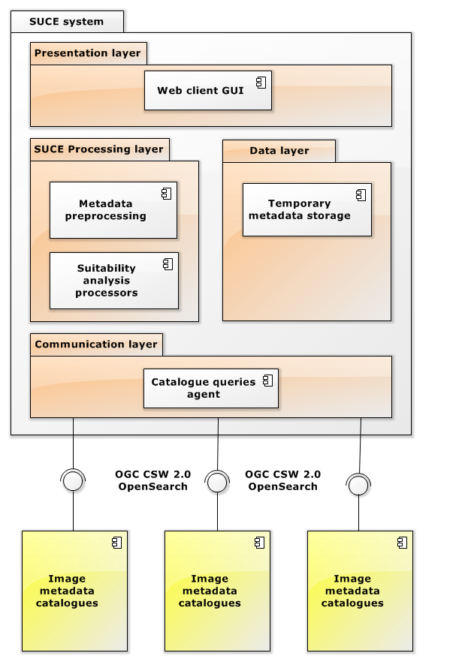

Figure 3: SUCE high level architecture.

At the beginning of the project there was no catalogue which would contain EO data with metadata information about cloud cover distribution that could have been used by SUCE engine directly. Therefore a SUCE CSW catalogue has been developed containing all necessary metadata for SUCE system, which allowed for full SUCE functionality demonstration. Nevertheless during the late stages of the project successful tests proving live connection to operational SciHub Catalogue have been performed in order to show wide possibilities to evolve SUCE idea towards operational usage. More detailed description of SUCE design is given in the Software Design Document [AD03].

## 2.3 Results evaluation

Results evaluation was focused on spatial coverage tool as the core of the SUCE prototype. It was performed as comparison of output of SUCE spatial algorithm and same procedure done manually or semi-manually.

Comparison task was designed as a manual preparation of images simulating mapping preparatory procedure from initial steps such as search images in available catalogue (EOLISA), their selection and composition in GIS until satisfactory image composition is achieved. Same task with same initial criteria was then performed in SUCE and results have been compared. Steps performed are summarized in the Table 3 below.

Table 3: Overview of SUCE evaluation task steps.

|  |  |
| --- | --- |
| **Steps performed manually in GIS** | **Steps performed automatically in SUCE** |
| Search EOLISA catalogue for available image products | Search SUCE catalogue for available image products |
| AOI: Czech (78 800 km2), TOI: 01/05/2001 – 15/09/2001, Missions: Landsat 5 / Landsat 7 | |
| Download selected subset / footprints | SUCE automatic processing. |
| Manually select the first suitable subset |
| Delete not suitable images |
| Search additional images to fill the gaps |
| Repeat previous steps until satisfactory image coverage is achieved or all possibilities tested |

Evaluation proved that results calculated by SUCE are of comparable quality but calculated in several seconds while manual task took several hours, metadata volume needed by SUCE were dramatically lower than for manual task. Results are summarized in the Table 4 below and output examples provided in the Figure 4. Detailed evaluation description can be found in Evaluation Report document [AD05].

Table 4: Overview of SUCE evaluation results.

|  |  |  |
| --- | --- | --- |
|  | **Task performed manually**  **in GIS** | **Task performed automatically**  **in SUCE** |
| Scenes found | 110 | 110 |
| Scenes used | 11 | 9 |
| Data volume transferred | **27.5 GB** | **55 MB** |
|  |  |  |
| **Overall time needed** | **470 minutes (~1 man-day)** | **17 seconds** |

Figure 4: Evaluation results comparison – upper image from manual task, lower image from automatic calculation performed by SUCE.

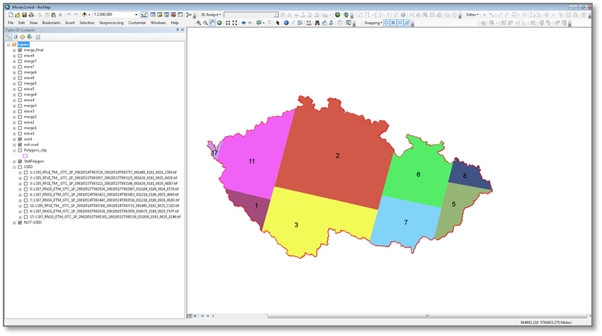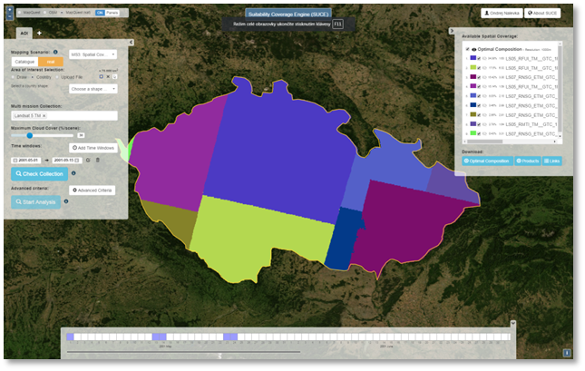

# 3. RECOMMENDATIONS & CONCLUSIONS

SUCE demonstrator proved to be beneficial in many user areas and in order to be transferred into an operational usage following requirements shall be met:

* Catalogues shall use the same search interface. Most suitable seems to be OpenSearch which provides a unique interface to a number of EO catalogues.
* Cloud mask has to be present in the metadata of the product with the option to be downloaded independently (without downloading the whole product).

Within the prototype evaluation users from various categories (EO expert, GIS expert, not EO expert), various domains (Image processing, GIS, Geography) have been asked to provide feedback on SUCE tool.

Feedback gathered from these users proved that:

* SUCE provides new analytical tool for EO community that significantly reduces subjective manual work and data transfer from EO archives.
* Analysis is possible only when catalogues metadata include link to Cloud Coverage layer (SUCE uses raster layer).
* SUCE can connect to ESA operational catalogue (SciHub) using FedEO compliant standards (OpenSearch) and offer a new functionality as an added value service on the top of these catalogues.

Beside the general conclusions users also recommended various improvements of the prototype mostly focused on user interface, but also on other functionality. These recommendations are listed in the Table 5 below.

Table 5: SUCE improvements recommendations.

|  |
| --- |
| **Comment / improvement recommendation** |
| **User interface** |
| Improve the Time window dates selection, not very user friendly. |
| Add informative messages for computation status and portal state (e.g. is there some error, is it hung, is it out of memory or is it still computing). |
| Add buttons/ functionalities (e.g. cancel analysis, go back to previous analysis, clear search, add AOI spatial buffer). |
| Download option for drawn AOI (as a shapefile / KML). |
| Improve colour coding of results to be better legible. |
| Portal shall provide solution for patching/covering holes caused by scattered clouds. |
| Provide information which country/shape is being processed for EEA39 (useful in case of big shapes taking long time). |
| Time estimation is not very accurate, improve. |
| More setting options before running analysis (e.g. minimal/maximal number of scenes). |
| **SUCE engine functionality** |
| Compactness value usage is questionable, shall be better explained. |
| Solution to avoid narrow stripes in coverage. |
| Option to give preference of temporal homogeneity to minimum number of scenes. |
| Time buffer functionality is questionable. |
| Multiple time windows functionality is questionable. |
| Option to define / adjust hard coded time windows (now used for EEA39). |
| Artefacts at edges of L5/L7 data cause slivers. |
| Solution to avoid memory overflow caused by big AOI/high resolution. |
| Improve algorithm to avoid slivers. |

More details about end user evaluation including questionnaires, along with other recommendations can be found in Evaluation Report document [AD05].

***<< End of the Document >>***