****

**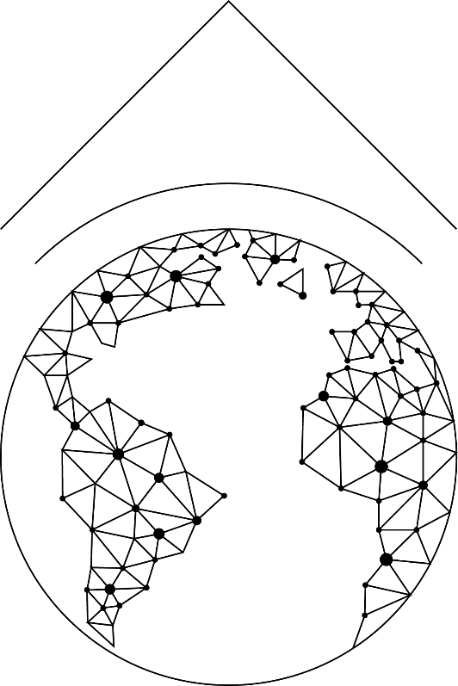**

TERRASIGNA

3 Logofat Luca Stroici St

020581 Bucharest, Romania

Prepared for:

ESRIN

Via Galileo Galilei

Casella Postale 64

00044 Frascati, Italy

Copyright © TERRASIGNA 2017

Executive Summary (publishable)

Data Mining For Analysis And Exploitation Of Next Generation Of Time Series

(DAMATS)

www.terrasigna.com

**Table of contentS**

[1 INTRODUCTION 4](#_Toc462675565)

[2 PROJECT OBJECTIVES 5](#_Toc462675566)

[3 PROJECT BREAKDOWN STRUCTURES 6](#_Toc462675567)

[4 PROJECT SCHEDULE 8](#_Toc462675568)

[5 WORK PERFORMED AND RESULTS 10](#_Toc462675569)

[6 RECOMMENDATIONS AND CONCLUSIONS 12](#_Toc462675570)

# INTRODUCTION

The present document represents the executive summary of the project **Data Mining For Analysis And Exploitation Of Next Generation Of Time Series (DAMATS)**, within the **General Support Technology Programme (GSTP 6 El. 1).**

It includes the following sections:

* Introduction;
* Project objectives;
* Project breakdown structure;
* Project schedule;
* Work performed and results;
* Recommendations and conclusions.

More details about DAMATS are presented on the project webpage: <http://wiki.services.eoportal.org/tiki-index.php?page=D>AMATS

# PROJECT OBJECTIVES

The main objective of the project was to develop DAMATS system that comprises general analytical methods for the exploitation of the information contained in Satellite Image Time Series (SITS). The main focus was on the information extraction in the form of “categories of evolution” and elaboration of technologies to classify the evolution processes of observed scenes.

In this context, the project aimed to analyse, develop and benchmark technologies to enable:

* Quick and effective generation of SITS;
* Definition and categorisation of classes having the same evolution in time (“categories of evolution”);
* Fast semantic searches of defined classes within huge image archives.
* In addition, the project will also address:
* The selection of SITS specific algorithms for the extraction of their inherent information content;
* Benchmarking activities for relevant SITS, including additional information sources;
* Implementation and validation of prototypes with relevant user communities, with related services made available over a virtualized environment.

# PROJECT BREAKDOWN STRUCTURE

The work Breakdown Structure for the project implementation is summarized below (Figure 1).

**C:\Users\mirela.CSCA\Documents\Business\Licitatii\2014_AO7967_DAMATS\Propunerea\Anca\WBS.tif**

*Figure 1 Work Breakdown Structure (WBS)*

# PROJECT SCHEDULE

The project duration is 24 months, between February 2015 and March 2017.

# 

# WORK PERFORMED AND RESULTS

This section presents the work performed and main project results:

* **Use Cases and Scenarios (Technical Note)**. A questionnaire presenting a short description of the proposed concept together with a list of the significant issues regarding the software functionality were sent via e-mail to a list of potential users.
* **User Requirements Document (Requirements Baseline)**. The user requirements for the development of the DAMATS prototype include: UR1 - General Requirements; UR2 - Specific Requirements;
* **Methods, Algorithms and Tool Technical Note**. As the DAMATS project addresses the need to provide access and control to large amounts of data, it enables tools for exploitation and manipulation of hidden information. It proposes an interdisciplinary approach combining specific procedures for specific data processing, learning, query and analysis. The prototype fits the particularities of Earth Observation data and it is able to allow the integration of additional data sources.
* **Software Requirements Specification (Technical Specification)**. The General User Interface guides the user through the entire process, allowing different interactions with the system, like the selection and visualization of the available scenes from the Local Database, or the selection of different functions from the Query Toolbox (e.g. searching, classification or labelling).
* **Software Design Document (Design Definition File)**. The system allows user interaction for three activities during the processing chain: 1. Access the database and select a dataset proper to the application scenario; 2. Perform content base image retrieval and knowledge discovery; 3. Exploratory data analytics and interactive and dynamic navigation.
* **Software Reuse File (Design Justification File)**. Several software applications have been reused to develop DAMATS prototype (Python, PostgreSQL, Apache, psycopg2; mod\_wsgi, EOxServer, MapServer, Django, PostGIS, GDAL, GEOS, PROJ, PIP, NumPy, SciPy, matplotlib, Scikit-learn; Open layers; jQuery, Bootstrap, D3.js);
* **Software Verification and Validation Plan (Design Justification File)**.An initial approach was determined for software verifications and validations to be performed in order to ensure the compliance of the DAMATS prototype with the Software Requirements Specification and the User Requirements.
* **Software Verification and Validation Report (Design Justification File)**. Test cases were performed for verifying the correct implementation and functionality of the software components, and for validating the DAMATS prototype.
* **DAMATS SW - User Manual**. It describes the basic functionalities of the DAMATS system and to guide the user through further employment.
* **Software Package (SP)**. It includes the software modules and installation instructions.

# RECOMMENDATIONS AND CONCLUSIONS

Based on the validation activities and the evaluations performed by external experts we may conclude that the DAMATS prototype is answering to the user requirements, as they were stated in the SoW and URD-RB documents. Nevertheless some suggestions and recommendations were made by ESA personnel and external experts, to improve the prototype in the perspective of a future use of the project outcome.

Here are some of the recommendations made by external evaluators:

* A general workflow shall be presented to the user to know what steps to perform and in which order, for getting the results.
* The previews of all available images in an area are loading very slowly in the GUI. A suggestion will be to display only the footprints of the available images. And the preview when the user is clicking on a footprint.
* It will be useful to create a SITS with images from different missions, in order to have more images available in a certain period of time.
* Statistics/quantitative measures about cumulative change are needed as on inspecting the colors is not very clear how big the changes were.
* It will be useful to have predefined scenarios for different use cases, like deforestation/changes in forest class in a certain region. And the classification to display in the results only the forest class, and the rest transparent.

One of the recommendations was to be better promote DAMATS in Universities, to encourage scientifically usage and increase awareness on the opportunities created by the temporal analysis at the academic level. This activity will stimulate the development of new dedicated algorithms and procedures.

By combining images from different missions (e.g. Landsat 8, Sentinel 2) in order to have a high image availability frequency, DAMATS can be used also to monitor change events over large areas and short periods of time (e.g. monitoring of sargassum weed in tropical islands).

DAMATS prototype could also be seen in perspective of a possible integration and deployment in a Collaborative Ground Segment infrastructure (e.g. in Romania), to support local/regional users and applications.