Real-time verification and testing facilities

# Description

The Real-Time Verification and Testing Facility is a modular and reconfigurable testbed, which allows for faster, less expensive, more flexible, and more modern GNC verification and validation of any space flight mission. It is designed for industrial maintainability and long-time availability.

|  |  |
| --- | --- |
| The testbench supports Model-in-the-Loop (MIL), Processor-in-the-Loop (PIL) and Hardware-in-the-Loop (HIL) verification types and allows testing in open-loop and closed-loop configurations.  The test platform makes use of commercial-off-the-shelf (COTS) items. The PIL and HIL platform environment uses the dSPACE SCALEXIO processing unit as central item. The SCALEIXO is simulating all model aspects which are not represented by real or flight representative hardware. To be able to integrate such hardware items into the environment, the SCALEXIO can be extended by COTS interface cards or make use of the built-in ethernet interface.  The integrated software is represented by the COTS software ASTOS, which is used as dynamics, kinematics and environment simulator. For PIL and HIL Simulink simulators are converted by the dSPACE software framework to a binary which can be executed by the SCALEXIO.  Figure 2 depicts the architecture of the testbed. |  |
| Figure 2: Hardware Architecture of HIL Platform with Image Processing on SCALEXIO |

The conversion of a MIL into a PIL platform can be separated into two major steps:

* Configuration of the dSPACE software framework to be able to auto-code the Simulink simulator to a binary which can be executed by the SCALEXIO.
* Configuration of the new target block in Simulink and trigger the auto-coding of the GNC algorithms for the flight representative mainboard LEON4-N2X in a Gaisler RASTA cradle.

For the HIL platform (see Figure 2) the simulation is connected to a robot arm using a Simulink toolbox, which commands the position and attitude of the robot arm’s end-effector and which handles all required transformations and scaling factors.

The simulation of the PIL or HIL platform is controlled by the ASTOS Operator GUI – a customizable GUI which is also able to modify parameters in the simulator and create plots in real-time during a simulation. The Operator GUI automatically uploads the configuration and created binaries to the SCALEXIO and RASTA before the simulation is started.

In the frame of this project a test bench has been implemented, which reduces clearly the effort of the GNC and test engineering setting up a test bench as part of a test facility. This allows him to focus on his main tasks, which is the onboard software and its validation.

It is expected that the new test bench will allow for faster, less expensive, and more flexible GNC verification and validation. It will be further developed and distributed as part of the ASTOS product family for all kind of space flight mission.

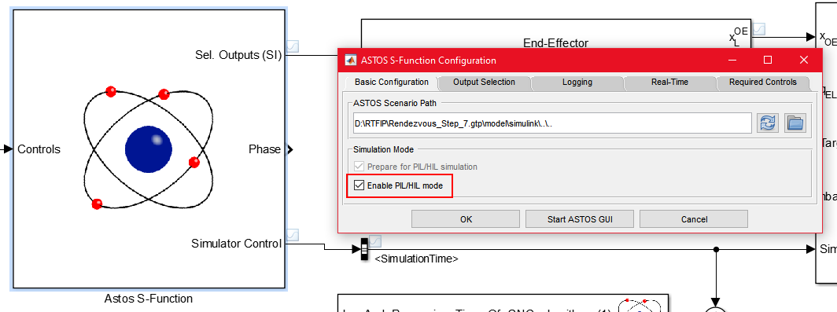

Figure 4: Switching of Platform

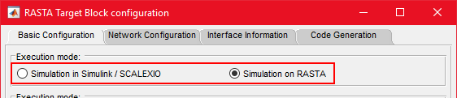

Figure 5: Switching of Execution Mode of GNC Algorithms

# Applications of the development

The developed testbench can be used for validation of GNC and AOCS algorithms of any kind of space flight mission. It supports MIL, PIL and HIL simulations.

It has been tested in the GRALS facility of the ESTEC GNC Laboratory which is dedicated to image-based navigation applications. Therefore, the test bench consisting of Control Workstation and dSPACE SCALEXIO has been connected to the KUKA robot arm in the GRALS facility and to flight representative LEON4-N2X board in a Gaisler RASTA cradle as depicted in figure 2.

Moreover, it is already in use for space transportation applications and in an extended version it is used as AOCS-SCOE for satellites.

# Technical fact sheet

The key technical facts are

* Flexible scenario configuration with ASTOS
* Reconfigurable
* Test engineer mode
* Suitable for MIL, PIL and HIL simulation
* Automated integration of RASTA platform
* Completely based on COTS software and hardware components, which are under continuous maintenance
* Flexible integration of KUKA robot arms in GRALS facility
* Separation of PIL and HIL platform specific configuration from simulator to be able to easily switch between MIL and PIL/HIL platform (see Figure 4, Figure 5)
* Realtime Camera and Lidar Simulator
* Multispectral camera simulation
* Support for Scanning and Flash Lidar

The Testbench will be further development and distributed as part of the ASTOS product family. A basic version of the testbench is already now available. An extended version with an improved software functionality based on the RTFIP project will be available in 2020.

# References

ASTOS-RTFIP-FR-001 Final Report

Contract No.: 4000122287/17/NL/CRS

Technical Officer: I. Huertas, A. Martinez Barrio

# Contact point

Email: sales@astos.de

Web: www.astos.de