Real-time verification and testing facilities

Executive Summary Report

Contract No.: 4000122287/17/NL/CRS

Technical Officer: I. Huertas, A. Martinez Barrio



|  |  |  |  |  |
| --- | --- | --- | --- | --- |
| Document Number: | ASTOS-RTFIP-ES-001 | |  | Date: |
| Issue: | 1.0 | |  | 2019-09-20 |
|  |  | |  |  |
|  | Name/Function | Organization | Signature |  |
| Prepared by: | Sebastian Winter | Astos Solutions |  | 2019-09-20 |
|  | Andreas Wiegand | Astos Solutions |  | 2019-09-20 |
|  |  |  |  |  |
|  |  |  |  |  |
|  |  |  |  |  |
| Checked by: | Sebastian Winter | Astos Solutions |  |  |
| Product Assurance: |  |  |  | - |
| Project Management: | Sebastian Winter | Astos Solutions |  | 2019-09-20 |

# Executive Summary

ESR EXECUTIVE SUMMARY REPORT

IRENE: 1-2 pages

The Executive Summary Report shall concisely summarise the

findings of the Contract. It shall be suitable for non-experts in the field

and should also be appropriate for publication. For this reason, it shall

not exceed 5 pages of text and 10 pages in total (1500 to 3000 words).

BR BROCHURE

IRENE: technical sheet what we can do 1pg 2-3 image

A brochure is intended for marketing purposes. It shall be concise,

including a short description of the work performed and applications

of the development, a photograph or functional drawing if applicable,

technical fact sheet, estimate of availability (delivery time) and a

contact point for marketing purposes. It shall contain 1 or 2 pages of

text (i.e. up to about 700 words).

FR FINAL REPORT

The Final Report shall provide a complete description of all the work

done during the study and shall be self-standing, not requiring to be

read in conjunction with reports previously issued. It shall cover the

whole scope of the study, i.e. a comprehensive introduction of the

context, a description of the programme of work and report on the

activities performed and the main results achieved.

The Final Report is a mandatory deliverable, due upon completion of

the work performed under the Contract. For the avoidance of doubt,

“completion of the work performed under the Contract” shall mean

the finalisation of a series of tasks as defined in a self-contained

Statement of Work.

The objective of this activity has been the design and development of a reconfigurable and high-fidelity testing facility for GNC verification and to demonstrate its capabilities in the GRALS facility of the ESTEC GNC Laboratory. The goal has been to achieve a faster, less expensive, more flexible, and more modern GNC verification and validation, which is designed for industrial maintainability and long-time availability.

The resulting testbench supports Model-in-the-Loop (MIL), Processor-in-the-Loop (PIL) and Hardware-in-the-Loop (HIL) verification types and allows testing in open-loop and closed-loop configurations. The facility is modular, supporting fast and flexible scenario configuration, and is movable and re-locatable.

The test platform makes use of commercial-off-the-shelf (COTS) items. The PIL and HIL platform the environment uses the dSPACE SCALEXIO processing unit as central item. The SCALEIXO is simulating all model aspects which are not represented by real or flight representative hardware. To be able to integrate such hardware items into the environment, the SCALEXIO can be extended by COTS interface cards or make use of the built-in ethernet interface. The integrated software is represented by the COTS software ASTOS, which is used as dynamics, kinematics and environment simulator. For PIL and HIL Simulink simulators are converted by the dSPACE software framework to a binary which can be executed by the SCALEXIO.

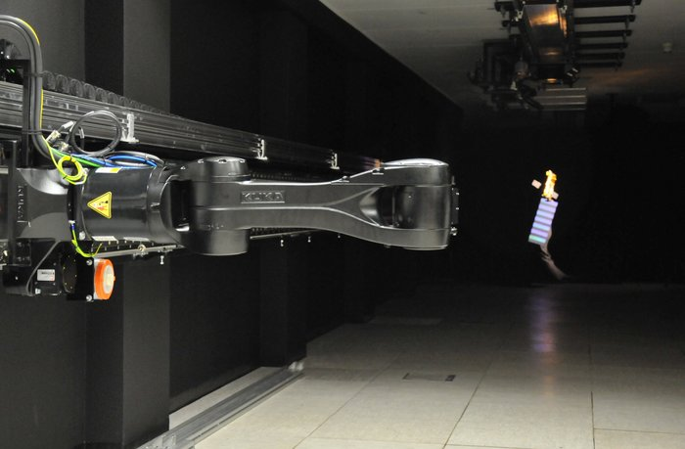

Figure 1: GRALS Testbed of ESA (source: ESA)

The capabilities of the test bench have been demonstrated in the GRALS facility of the ESTEC GNC Laboratory (see Figure 1). Therefore, the test bench consisting of Control Workstation and dSPACE SCALEXIO has been connected to the KUKA robot arm in the GRALS facility and to flight representative LEON4-N2X board in a Gaisler RASTA cradle as depicted in Figure 2.

Figure 3 depicts the software architecture of the test facility and how it changes from MIL to PIL and HIL. The conversion of a MIL into a PIL platform can be separated into two major steps:

* Configuration of the dSPACE software framework to be able to auto-code the Simulink simulator to a binary which can be executed by the SCALEXIO.
* Configuration of the new target block in Simulink and trigger the auto-coding of the GNC algorithms for the LEON4-N2X board.

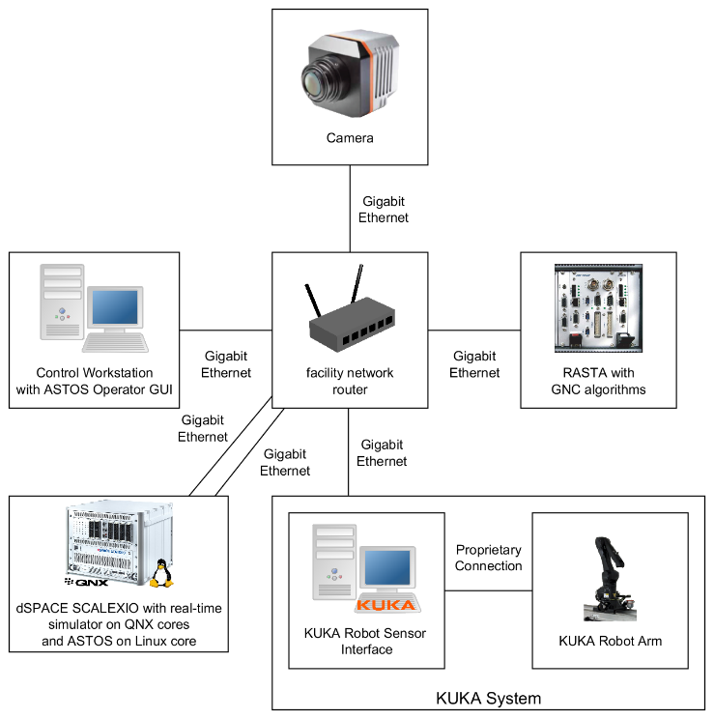

Figure 2: Hardware Architecture of HIL Platform with Image Processing on SCALEXIO

The configuration for both steps can be stored outside the original MIL simulator. Therefore, after the configuration was created once the user is able to switch between MIL and PIL/HIL by changing the simulation mode (see Figure 4) and the execution of the GNC algorithm (see Figure 5) directly in Simulink. Therefore, one Simulink simulator can be shared between platforms.

For the HIL platform (see Figure 2) the simulation is connected to a robot arm. To connect the robot arm of the GRALS facility to the simulator a set of Simulink blocks were developed. Based on the simulated scenarios the blocks are responsible to command the position and attitude of the robot arm’s end-effector. The blocks handle all required transformations and scaling factors. The developed blocks can be used for MIL and HIL platforms. Therefore, they have no impact on the easy switching mechanism described above.

The simulation of the PIL or HIL platform is controlled by the ASTOS Operator GUI – a customizable GUI which is also able to modify parameters in the simulator and create plots in real-time during a simulation. The Operator GUI automatically uploads the configuration and created binaries to the SCALEXIO and RASTA before the simulation is started.

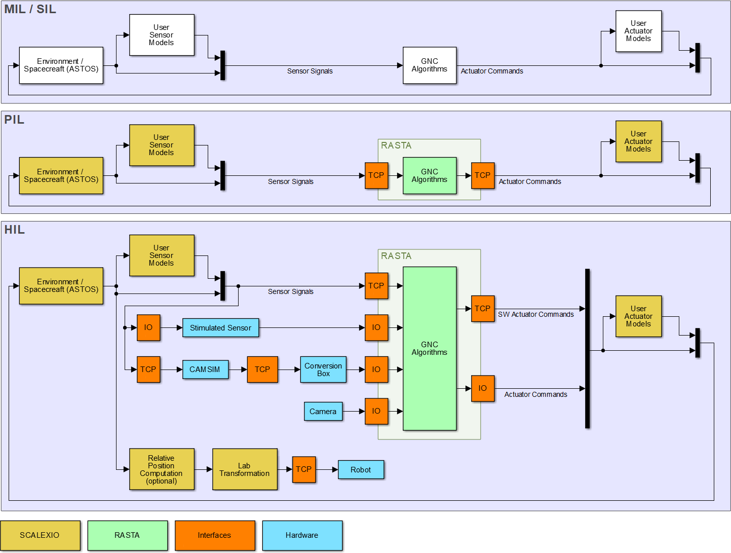

Figure : Test Facility Architecture

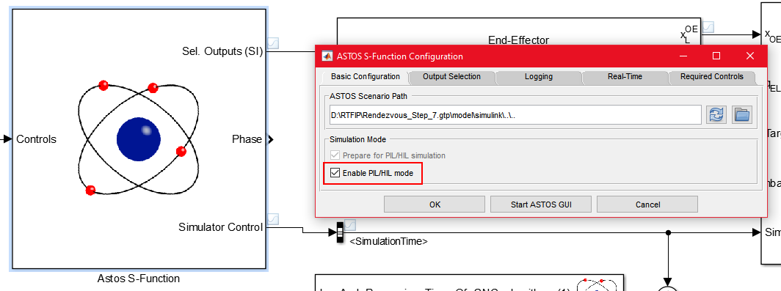

Figure : Switching of Platform

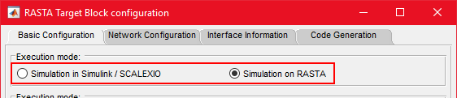

Figure : Switching of Execution Mode of GNC Algorithms

In the frame of this project a test bench has been implemented, which reduces clearly the effort of the GNC and test engineering setting up a test bench as part of a test facility. This allows him to focus on his main tasks, which is the onboard software and its validation.

It is expected that the new test bench will allow for faster, less expensive, and more flexible GNC verification and validation. It will be further developed and distributed as part of the ASTOS product family for all kind of space flight mission.