**Express Procurement Plus - EXPRO+**

**Microwave heating of ISRU feedstock**

**MICROwaves heating for sintering of regoLITH - MICROLITH**

**ESR – Executive Summary Report**

Contents

List of Figures 3

List of Tables 4

Abbreviation List 5

1 Introduction 6

2 Executive Summary Report 6

# List of Figures

Figure 1 - Project Phases 6

Figure 2 - Different levels of test 7

Figure 3 - Preliminary solutions 8

# List of Tables

Table 1 – MM Samples Densities 9

# Abbreviation List

|  |  |
| --- | --- |
| **CNC** | Computerized Numeric Control |
| **SEM-EDS** | Scanning Electron Microscope and and Energy Dispersive X-ray Spectroscopy |

# Introduction

The scope of this Executive Summary Report is to briefly provide a general summary of the activities performed during the whole project. The activities developed can be recapped as hereafter shown in the scheme. In the following section each step will be further described and illustrated.

Figure 1 - Project Phases

# Executive Summary Report

The first activity of the project has been the performing of a detailed analysis of the state-of-the-art, with focus on lunar soils and terrestrial simulants characteristics. This phase has been useful to underline the peculiarities of the regolith and of the terrestrial simulants.

In parallel, the Team worked on the selection and the preparation of the samples of regolith simulants, and on the identification of the microwave heating technique.

For what concern the terrestrial simulant, a material coded DNA-1 has been chosen. Such material is available from a quarry near Bolsena Lake, about 100 Kms North of Rome. The material originated by ancient volcanic events has been selected since the chemistry and mineralogy are quite similar to lunar regolith. Once the collection of the simulant material from the quarry has been completed, a detailed set of analysis and characterizations has been performed to evaluate the possible mimic of such material of the real lunar regolith in relation to the aim of the activities, namely the densification by sintering. In such context, combining the data achieved from the DNA-1 characterization with the related features and peculiarities of lunar regolith and of already known terrestrial simulants (thanks to the state-of-the art review), eight different solutions (simulant versions) have been produced. These solutions, called Master Materials, cover a range from proper granulometric fractions of the DNA-1 as received up to augmented versions of it obtained by an ‘’artificial’’ vitrification process and adding high purity commercial ilmenite. In such a way, the Master Materials give the possibility to evaluate the possible impact of relevant differences typically present on lunar regolith (e.g. depth to the surface, quantity of Fe2+, related abundance of glassy phases due to agglutinates and lunar glasses) on the microwave induced sintering process.

A further step in the project has been identifying the proper device to implement the microwave heating technique. The output of this activity has been the identification of a solid-state microwave generator, with characteristics suitable for the project experimental tests. The frequency of the microwave source has been selected at 2450 MHz with a power adjustable from 0 to a maximum of 500W. A device with these characteristics would be particularly suitable for operations in the lunar environment, but, at the moment, further developments are necessary for make it capable to operate in conditions of extreme low pressure.

Other devices necessary for developing the Test Setup have been identified and shown hereafter.

* Vacuum Chamber, focusing the attention on the chamber optimization for sample treatment maximizing the capacity to obtain low pressure conditions.
* A 3 axis CNC control system: an automatic device able to move the antenna tips toward the powder based on a particular movement established and previously planned.

Based on the selection of the needed subsystems, the Partnership proceeded with the system design, the definition of test cases and the drafting of the related procedures. Then, the description of the interfaces between the submodules which composes the Test Setup have been carried out, with details related on the specific characteristic of each submodule. The experimental plan has been organized in three different levels of test as shown in the following picture.

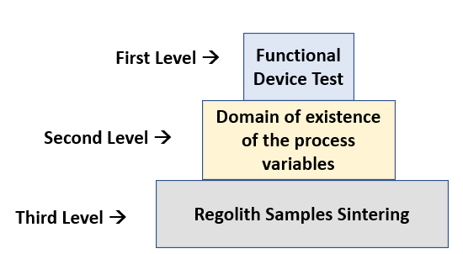

Figure 2 - Different levels of test

After the completion of the previous stages, the Test Setup has been assembled. During this phase a tuning of the system parameters, with particular attention to the reflected power and the minimization of the corona discharge phenomenon has been performed. These activities have been preparatory for the execution of the Functional Tests.

All the functional Tests and the relative results were performed at room pressure.

A preliminary set of tests in vacuum condition have been performed to optimize the strategy for the actual sample sintering phase.

The final step has been to perform the sintering tests on the simulant powders and to provide the related results.

The tests performed during the project demonstrate that adopting the technology based on microwave heating, and specifically on solid-state generators for sintering applications, is a valid and promising solution.

During the test has been necessary to overcome some practical issues, in particular the sticking of the powder to the antenna tip when operating in low pressure conditions, namely 10-2 mbar. The cause is the corona discharge phenomenon that implies the need to decrease the power thus implying a position of the antenna tip close to the powder bed that favours the sticking. To mitigate this issue, different strategies have been studied and implemented. The results highlighted that, at the moment, the specific Test Setup needs further developments and optimizations in order to avoid the powder sticking to the antenna tip. Some possibilities, illustrated in Figure 3, have been considered.

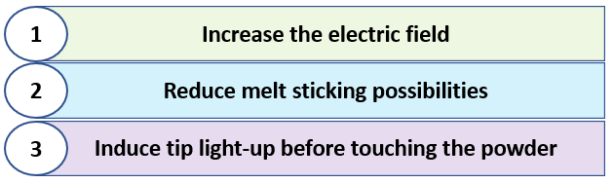

Figure 3 - Preliminary solutions

For what previously described these kind of solutions needs further studies and analysis in order to open the possibility to prototype this system to perform operations on the moon environment.

During the sintering tests, starting from each Master Material, a set of specimens has been produced, handled, and the specific characteristics have been studied. As aforementioned, the differences among the Master Materials gave the possibility to perform an evaluation of the impact on the results obtained according to the purposely induced differences in these materials (e.g. glassy phases, ilmenite).

Analyses have been carried out to elaborate the density and porosity of the samples obtained by the sintering process. Additional characterizations included microscopic/microchemical investigations by SEM-EDS and the measurement of hardness and Young modulus by nano-indentation technique both carried out on the densified structures in the different cases.

In particular, as shown in the following Table 1, the Master Materials MM4, MM7 and MM8 presents average densities in line with the expected results for what concerns the samples for electrolysis (>1.3 g/cm3), while the MM8 is characterized by an average density very close to what expected for the samples for constructions (>2.0 g/cm3).

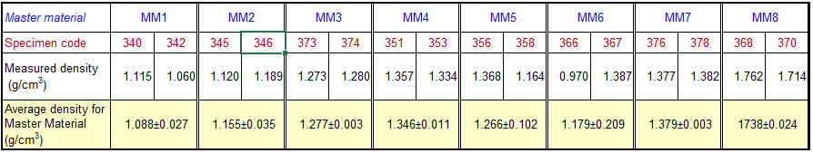

Table 1 – MM Samples Densities

Hereafter are highlighted the results of the characterizations.

* The specimens obtained by microwave heating have a global status constituted by an inner part derived from the molten and then quick solidification of the original MMs powder mixture covered by an external skin of sintered powder this last with a variable thickness of few tens up to few hundreds of microns.
* The microwave heating was effective in all the cases (all MMs) indicating that the simulant with and without modifications can be heated by such technique.
* The use of a wider (and coarser) granulometric distribution of the powder mixture (<600 µm) allows to obtain better results in terms of material densification than in case of finer one (<250 µm).
* The presence of vitrified phases as well as the presence of ilmenite (as in the real lunar soils) seems to be beneficial making possible to obtain better densification of the obtained specimens.
* The best cases are obtained with MM8 mixture that includes 35% vitrified DNA-1, 12% ilmenite. On the other hand, the range of density obtained can be considered for electrolysis, not for construction. This mixture is also the best performing in terms of both hardness and Young modulus.

According to the hypothesis that the dissipative discharge phenomenon is limited to a given range of low pressures below the atmospheric pressure, sintering trials have also been done in air at room pressure. The results indicated that without sticking it is possible to produce massive sintered having approximate dimensions 11x11x6.5 millimeters.

As last step of the project, a roadmap, a cost and a timeline estimation for a lunar demonstrator development have been carried out.

The estimation provides the information useful to move forward with the technology development, based on the estimated level of effort, in terms of time and cost.