|  |  |  |  |  |  |  |
| --- | --- | --- | --- | --- | --- | --- |
| **STUDY REPORT** | | | | | Date :  Pages Nb:  Annex Nb: | 26/06/2019  15  / |
| ***Reference: RE190125*** | | | | | | |
| **Topic:** | ESA AO 1-8763/16/NL/KML—Curing on Demand—Polymerisation by Switchable Stimulus  **EXECUTIVE SUMMARY REPORT – ESR** | | | | | |
| **Recipient:** | European Space Agency | | | | | |
| **Reference (RESCOLL): ProposalN°162716** | |  | | | | |
| **PO reference (customer):**  **ESA Contract N°4000119302/16/NL/KML –Curing on Demand Polymerisation by Switchable Stimulus** | | | | | | |
| **Final report  Intermediary report** | | | | | | |
| **Previous reports:** | | | | | | |
| **Diffusion :** | | | | | | |
| * Shumit DAS (ESA) * Karine MAGNE-LIE (ESA) | | |  | * Brigitte DEFOORT (Airbus Safran Launchers) * Xavier COQUERET (ICMR) * Michael SCHEERER (AAC) | | |
| **Author(s) (Name – Function): M.OLIVE** | | | | | | |

|  |  |  |
| --- | --- | --- |
| **Project manager**  **Signature:** | **Technical Expert**  **Signature:** | **Head of R&T Department**  **Signature:** |

E049H – 06/01/16

# Introduction

Space structures commonly utilize composite panels joined using adhesives and mechanical techniques. In most cases, CFRP composites are based on epoxy-amine systems, and are cured using thermal activation. The curing temperature is a trade-off mainly between the thermo-mechanical properties of the material and the pot-life of the prepreg or adhesive.

The use of latent initiators requiring a specific stimulus opens up an opportunity to cope with the need for extended storage, and to have materials with adequate reactivity and thermo-mechanical performance.

Conventional thermosets for fiber-reinforced composites have a limited pot life and constrained processing temperature windows. Latent initiating systems currently gain increasing attention, especially epoxy resins cured by cationic homo polymerization as investigated in this project.

The main technical objectives of the project are (i) to develop a set of latent initiator packages for curing a composite system meeting the needs of the target applications, (ii) to define typical curing conditions with a precise set of processing parameters and (iii) to assess the performances of resulting composite materials, with the perspective of proposing a sound development plan for the validated technology. An overview of the proposed approach is presented below.

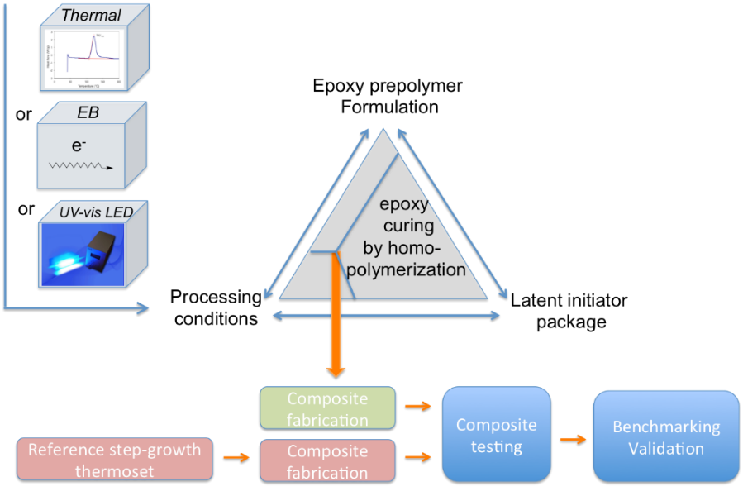

The project was leaded by RESCOLL (Prime) with 3 sub-contractors: ICMR (Institut de Chimie Moléculaire de Reims), AAC (Advanced Aerospace Composites) and ARIANE GROUP, with the following work breakdown structure (WBS).

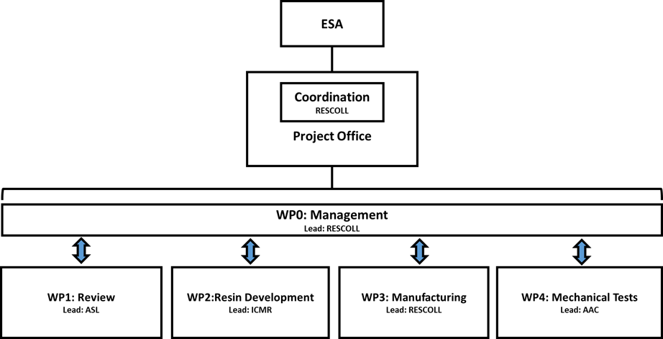

In addition to this WP structure, the following work flow was implemented in order to enhance the level of performance of the composite samples, from the production of the 1st series of samples (Batches 1&2) to the 2nd one (Final Batch), with the feedback and optimization loop.

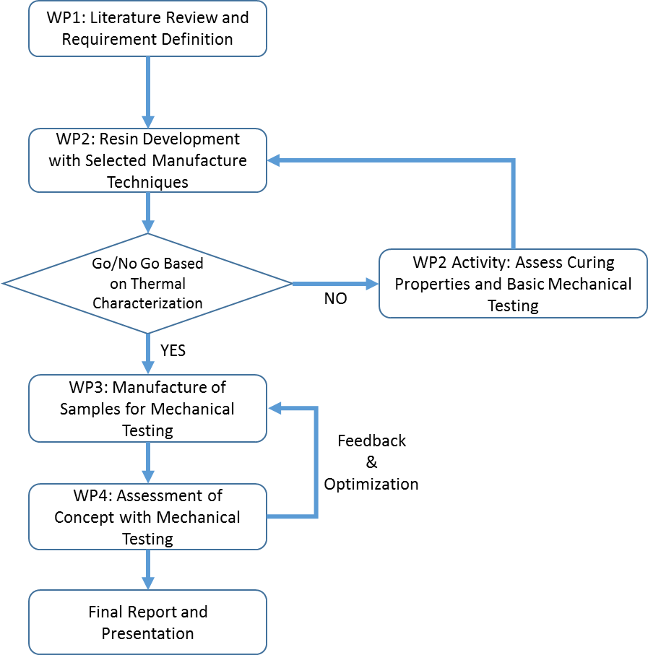

# Requirements on resins and composites

ARIANE GROUP proposed the list of requirements for resins and composites. Most important points are summarized below, they were used during the project for the development of resin systems in WP2 and the manufacturing and testing of composite (carbon based) materials in WP3 and WP4.

The requirements concern the material properties before polymerization, during curing and once the composite is fully manufactured.

## Resin requirements

### Uncured resin

The storage of each part or constituent has to fulfil the requirements given in the table below.

|  |  |  |
| --- | --- | --- |
| **Conditions** | **Unit** | **Requirements** |
| Room temperature (preferably) | Months | ≥ 12 |
| Between 4°C and 6°C | Months | ≥ 12 |

The thermoset resins must allow easy manufacturing process, as for example impregnation of roving (carbon fiber, glass fiber…) without solvent. Commonly, the volume ratio of fiber is around 60%.

The viscosity of the uncured resin for the impregnation process has to fulfil the requirements given in the table below

|  |  |  |  |  |  |
| --- | --- | --- | --- | --- | --- |
| **Characteristic** | | **Condition** | **Criteria** | **Requirements** | **Comments** |
| Viscosity | (mPa.s) | Room Temperature | Optional | < 1 000 000 |  |
| Viscosity | (mPa.s) | T°impregnation | Optional | ≤ 1 000 | T°impregnation ≤ 80°C |
| Pot life | hours | T°impregnation | Optional | ≥ 4 | Viscosity shall be <2 000mPa.s for at least 4 hours |

### Requirements for cured composites

#### Tg by DMA

The requirements on Tg (wet) are given in the table below (similar for cured resin)

|  |  |  |  |  |  |
| --- | --- | --- | --- | --- | --- |
| **Characteristic** | | **Condition** | **Criteria** | **Requirements** | **Comments** |
| Glass transition temperature by DMA  Frequency mode=1Hz  Heat-up rate=5°C/min | Tg onset  (°C) | Wet (at equilibrium: after humid aging at min 70% RH) | Mandatory (class 1) | 120°C | T°cure cycle  ≤ 130°C |
| Mandatory (class 2) | 150°C | T°cure cycle  ≤ 160°C |
| Optional (class 2) | 180°C | T°cure cycle  ≤ 190°C |

#### Outgassing

For use in some space application, cured material shall comply with the ECSS relating to outgassing (ECSS Q70 02).

#### Mechanical properties

The data below are given as reference.

|  |  |  |  |  |  |
| --- | --- | --- | --- | --- | --- |
| **Characteristic** | | **Condition** | **Criteria** | **Requirements** | **Comments** |
| Toughness | G1C  (J/m²) | Dry  at 23°C | Optional | ≥ 500 | - higher is better  - lower could be accepted according to the other performances |
| ILSS | MPa | Dry  at 23°C | Optional | 70 |  |
| Tensile 0° | MPa | Dry  at 23°C | Optional | 800 |  |
| Tensile +/-45° | MPa | Dry  at 23°C | Optional | 100 |  |

# Resin development

### Rationale of the experimental approach

Based on the conclusions of TN1B (literature survey) and decisions taken, the work conducted in WP2 was aiming at :

1. Selecting **a start-point epoxy formulation** presenting a set of acceptable properties (shelf-life, viscosity before curing, reactivity during curing, thermophysical and mechanical properties after curing) and offering the possibility to be further improved by formulation with appropriate additives,
2. developing a set of **latent initiator packages** for curing the matrix meeting the needs of the target applications,
3. defining typical **curing conditions** with a precise set of processing parameters,
4. assessing the **performances of resulting matrices**.

### Two generations of matrices

An iterative approach was followed leading to the definition of epoxy formulations without toughening additive (generation 1) and then including a thermoplastic PES (generation 2) special attention being paid to viscosity and polymerization onset in a proper temperature range.

The polymerization rate under the selected curing conditions (thermal, UV-vis LED, EB), was adjusted by a second iterative approach of the initiator package.

Two generations of matrix formulations were proposed to meet the requirements, In addition, a reference material, based on a conventional curing agent (DDS) was proposed as a reference for work in WP3 & 4.

Latent initiating systems, shown in the table below, were carefully designed for ensuring a large processing window and excellent stability on storage.

|  |  |  |
| --- | --- | --- |
| **Activation method** | **Co-initiators** | **Cationic initiator** |
| Thermal curing  (thermal energy) | Organic peroxide (<5 wt-%) | Diaryliodonium salt  (<3 wt-%) |
| UV- vis curing  (LED 385 nm)  (photons) | Tioxanthone |
| EB curing  (thermalized and R°) | None |

Adjustment of the viscosity as well as of the stability on storage and during processing at moderate temperatures (uncured state) and of the glass transition of the cured material were achieved by adapting the composition

### Characterization

The results obtained in WP2 (see next figure) showed that curing can be triggered under well-defined thermal or radiative treatment to yield epoxy networks exhibiting Tg’s typically around 150°C.

The temperature and kinetic profiles during the curing process influence the morphology of matrices including PES as a toughening agent (phase separation or not), as depicted in the next figure.

The influence of the amount of PES in formulations on ultimate mechanical properties of cured matrices should be further investigated.

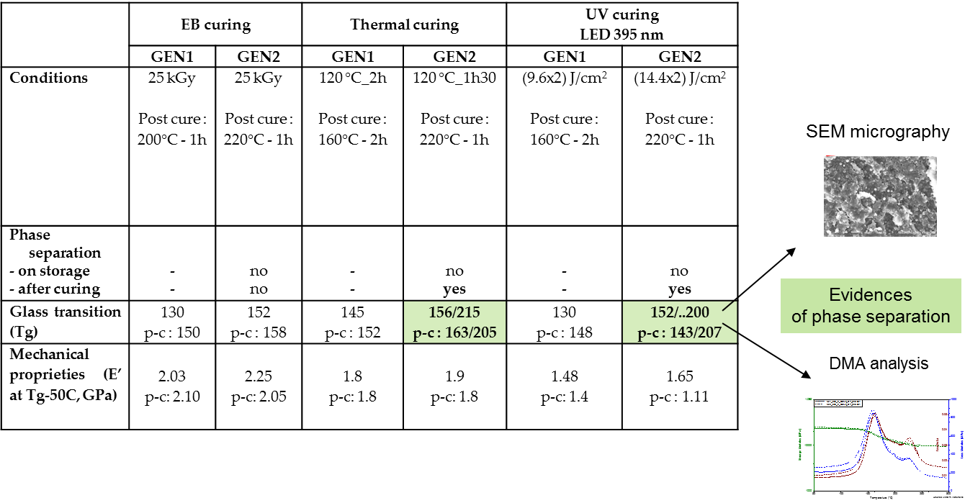

The conclusion of the work carried out for the development of the resins were the following:

* A Higher Tg was observed for GEN2 systems
* A Viscosity of 1-2Pa.s @ 70°C was reached, in compliance with ARIANE GP requirements for GEN2
* Shelf life: >6 months at RT and 1 week at 80°C
* GEN 2 systems were selected for manufacturing of Carbon Fiber Reinforced Polymers (CFRP) cured with EB and T

# CFRP manufacturing

## From Batches 1&2 to Final Batch: consolidation of the manufacturing process

The protocol used for the production of the CFRP plates was based on manual impregnation of the carbon fabric on a hot plate, followed by consolidation under vacuum and subsequent cure (in vacuum bag).

The manufacturing trials and mechanical tests performed on samples from Batches 1&2 highlighted high porosity levels in the CFRPs and low matrix-fiber interaction (low ILSS and IPS values). Consolidation work was then implemented in order to improve material density (reduced porosity) and increase fiber-resin compatibility, with 1/ change of the processing conditions (better material compaction) and 2/ treatment of the carbon fabric in order to improve adhesion of the resin on the fiber. This approach is summarized in the following figure.

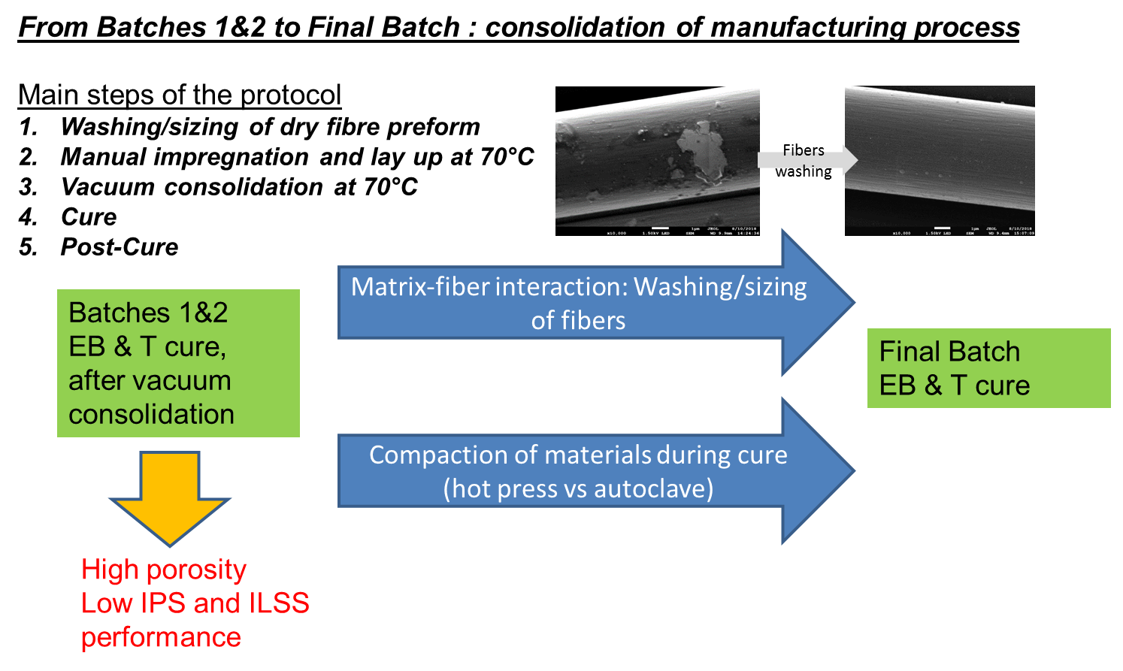

## Manufacturing process for the Final Batch

Due to the specific chemistry of the resin (cationic cure) a specific selection and stacking of consumables must be used to avoid cure inhibition, as depicted below.

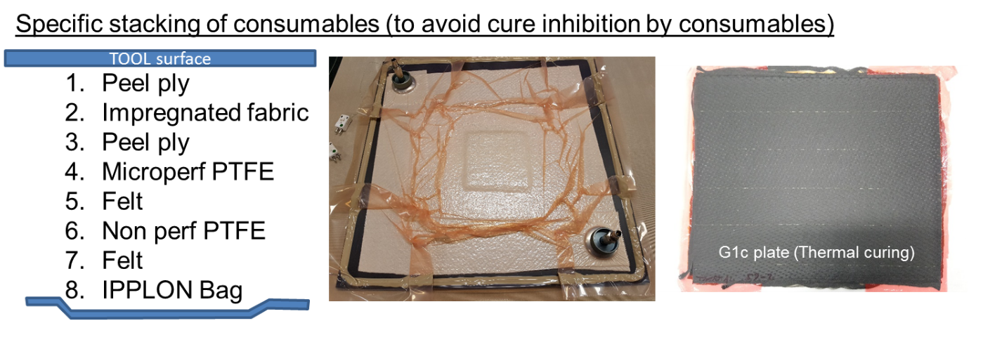

Based on the consolidation work, some light changes in curing protocol were used for the Final Batch. The new manufacturing process is detailed below.

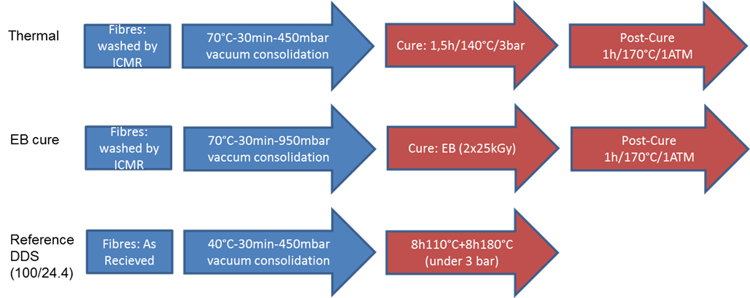

# Final Batch – Test & Results

## Test Plan

The test plan for the Final Batch is detailed below (tests vs number of samples).

|  |  |  |  |  |
| --- | --- | --- | --- | --- |
| **Thermo-mechanical characterization** |  | **Conventional** | **EB** | **THERMAL** |
| DMA | X | X | X |
| Fiber content (volumic) | X | X | X |
| Outgassing | 3 | 3 | 3 |
| **Before Thermal cycling** | ILSS | 7 | 7 | 7 |
| G1C Mode 1 | 7 | 7 | 7 |
| Tensile 0° | 6 | 6 | 6 |
| Tensile +45/-45 | 5 | 5 | 5 |
| **After thermal cycling\*** | ILSS | 7 | 7 | 7 |
| G1C Mode 1 | 7 | 7 | 7 |
| Tensile 0° | - | - | - |
| Tensile +45/-45 | 5 | 5 | 5 |

***\*****100 thermal cycles between -100°C and 100°C with a heating rate of 8K/min and a dwell time of 10 minutes*

## Results

### NDI (C-Scan) and volumic fiber content

The NDI inspection carried out on the test coupons led to the following conclusions:

* The quality of the conventional and thermal cured samples was clearly better compared to the 1st two batches of samples – clearly smaller damping indicating lower porosity
* An inspection of the G1C samples for the conventional and thermal cured samples was possible and the location of the Teflon inserts as crack starters can be clearly seen for the conventional and thermal cured samples
* The damping of the EB cured samples was similar to the first batches of EB samples and no inspection of the G1C samples were possible indicating similar damping and porosity as the 1st two batches of EB cured samples

This is clearly depicted in the next picture (G1c samples, from left to right: conventional –DDS , EB cure, Thermal cure). The EB cure is not visible with C-Scan, with means high porosity.

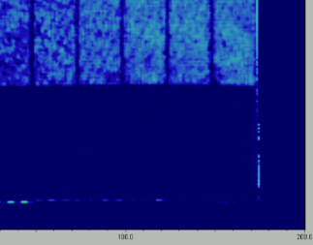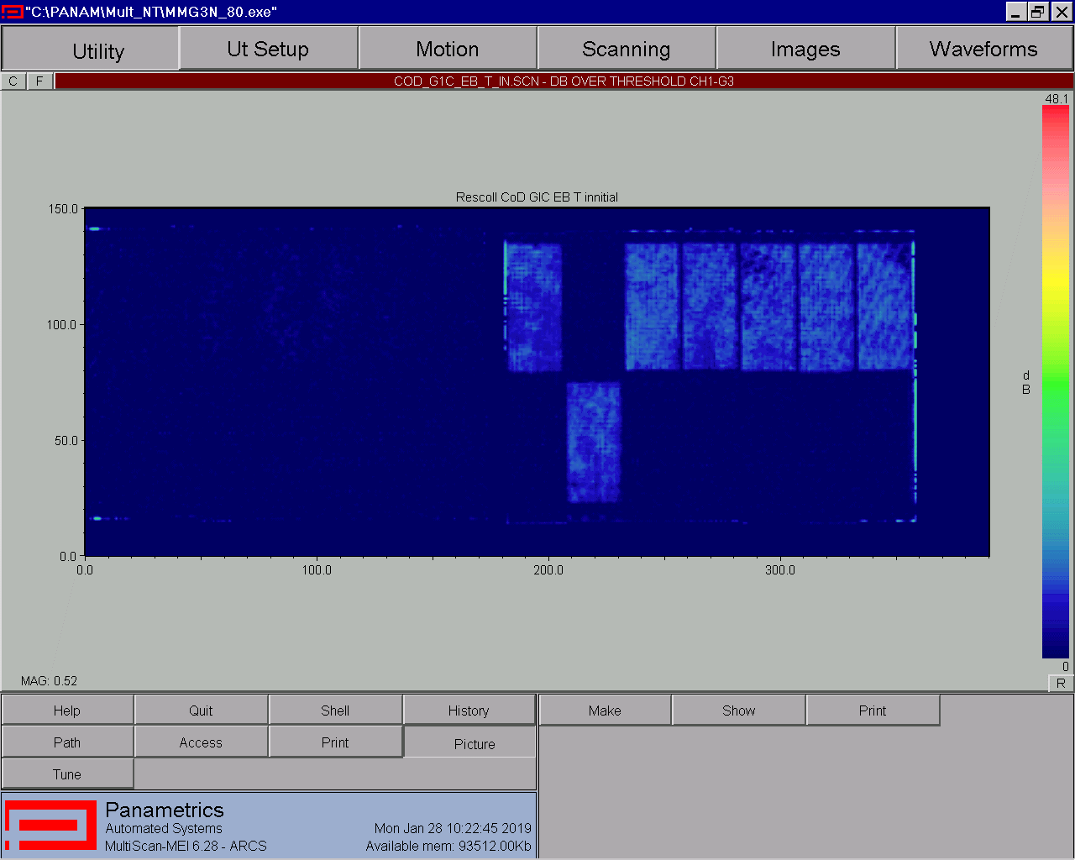

The C-Scan inspection is in line with the results of volumic fiber content (see below), with high porosity, in red, for EB samples.

|  |  |  |  |
| --- | --- | --- | --- |
| **Sample** | **Volumic Fiber Content (%)** | **Volumic Resin Content (%)** | **Volumic Porosity Content (%)** |
| **Thermal (053)** | 65,79 | 34,14 | 0,07 |
| 66,16 | 33,81 | 0,03 |
| **Thermal (059-1)** | 67,05 | 32,33 | 0,62 |
| 64,94 | 35,58 | -0,52 |
| **Thermal (059-2) – G1c** | 62,83 | 36,54 | 0,63 |
| 61,13 | 38,95 | -0,08 |
| **EB (055-1)** | 56,20 | 42,64 | 1,16 |
| 61,83 | 37,43 | 0,74 |
| **EB (055-2)** | 48,20 | 51,40 | 0,40 |
| 59,55 | 39,49 | 0,96 |
| **EB (055-3) – G1c** | 55,30 | 42,27 | 2,42 |
| 54,45 | 43,98 | 1,57 |
| **Reference (062-1)** | 65,84 | 34,67 | -0,51 |
| 61,69 | 39,62 | -1,32 |
| **Reference (062-2)** | 66,16 | 34,89 | -1,06 |
| 64,99 | 36,61 | -1,60 |
| **Reference (062-3) – G1c** | 65,92 | 35,47 | -1,39 |
| 66,22 | 35,23 | -1,45 |

High fiber content was observed on all samples (EB samples were however richer in resin). Higher porosity level was observed for EB samples (but better than Batches 1 & 2), which was directly due to the manufacturing protocol of EB samples (only packed under vacuum, with no overpressure).

### Tg by DMA

The thermomechanical properties of the samples were investigated by DMA, as summarized in the following table.

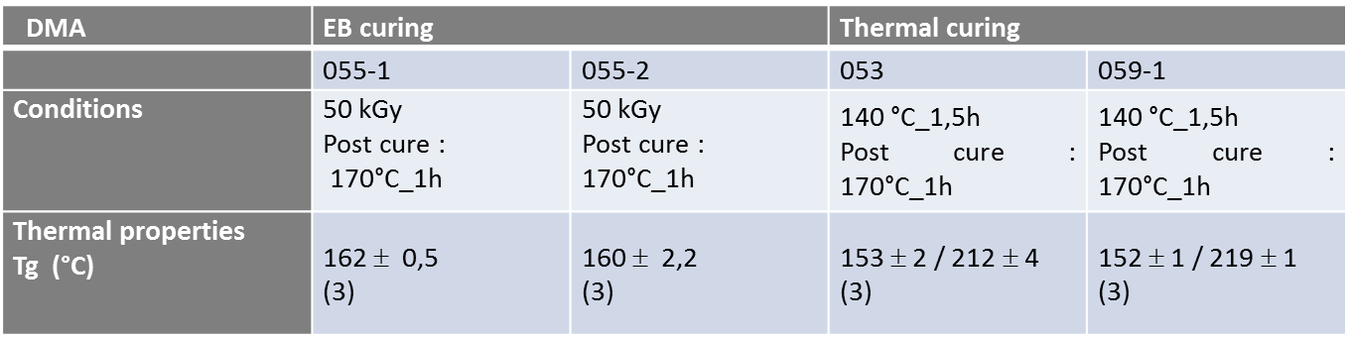

The values of Tg measured for the samples are in line with the observations realized in WP2 and Batches1&2, with phase separation in thermal cure and not visible in EB cure.

### Outgassing

Outgassing tests were performed according to ECSS-Q-70-02 at a temperature of 125°C for 24 hours in vacuum.

The next figure show the result of the outgassing tests: TML, RML and CVCM together with its critical limits.

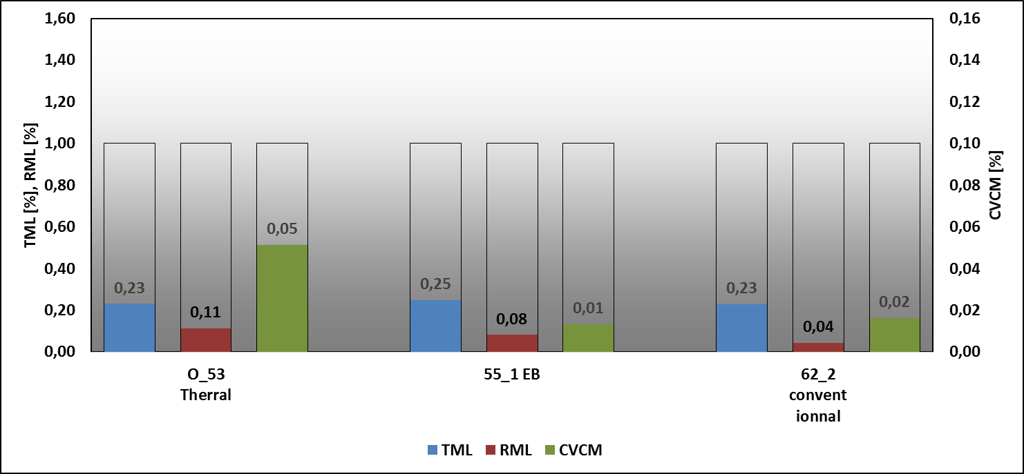

The 3 materials comply with the requirements from ARIANE GROUP, based on ECSS Q70 02:

* TML (Total mass loss) < 1%
* CVCM (condensed volatiles collected materials) < 0,1%

### Mechanical tests

The following figures show the average values of the mechanical values for the different batches of production runs (Final Batch vs Batches 1&2).

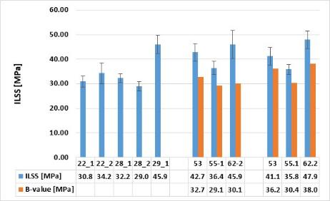 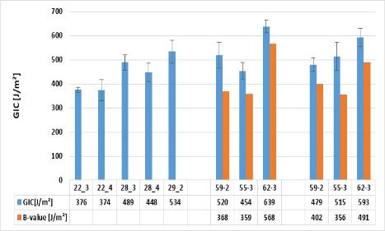

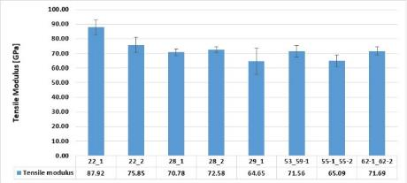 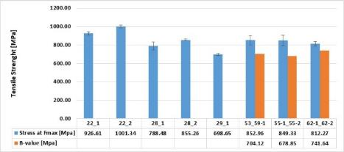

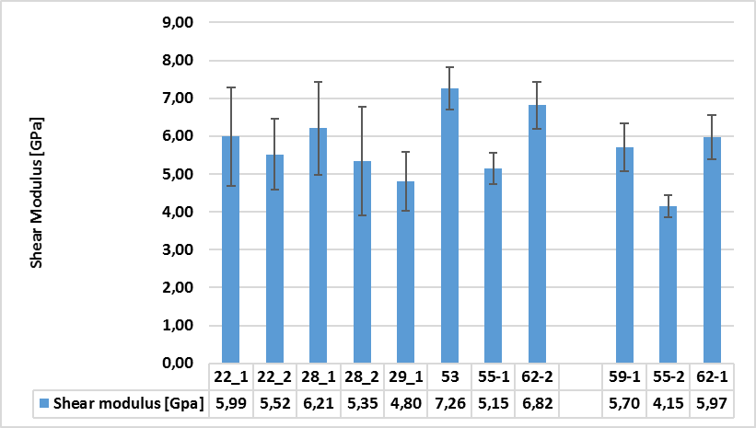

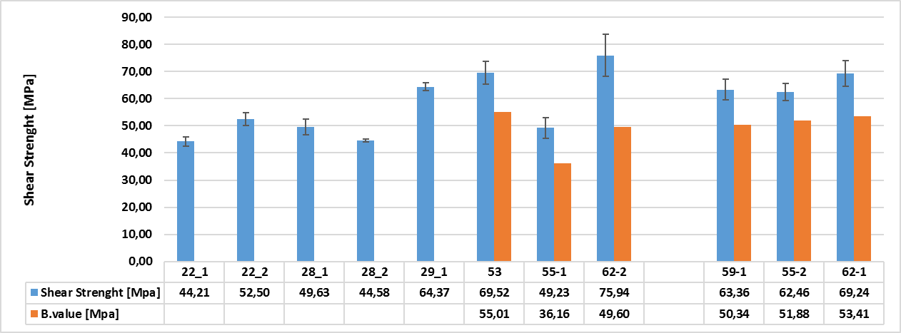

The following conclusions can be drawn out of the mechanical test results of all batches:

* The quality of the produced conventional and thermal cured samples for the Final Batch was clearly improved, which was demonstrated by the reduced damping of the US signal indicating a reduced pore content
* The quality of the EB cured samples was similar to the batches 1 and 2
* Especially the matrix dominant properties (ILSS, G1C and IPS) were better compared to batches 1 and 2
* The lowest values for the matrix dominant properties (ILSS, G1C and IPS) were observed for the EB cured samples before thermal cycling
* G1C and IPS properties increase for the EB cured samples after thermal cycling indicating a potential post-cure due to thermal cycling
* For the conventional and thermal cured samples both G1C and IPS decrease slightly after thermal cycling
* Tensile strength in fiber direction and G1C of the final batches reach the required values of 800 MPa and 500 J/m²
* ILSS and IPS of the final batches are clearly below the required values of 70 MPa and 100 MPa

# Assessment of the technology

## Recommendations to increase TRL

### Control of Generation 2 matrix morphology by using different modes of activation

The selected methods of activation have specific features in terms of temperature and kinetic profiles along the curing process. This results in quite contrasting conditions, with long curing times at temperatures close to the expected final Tg (thermal curing for some hours) or fast polymerization taking place within few minutes and starting at room temperature for the EB treatment. Thus, depending on the rate and on the thermodynamic conditions, the polymerization-induced phase separation of the thermoplastic component yields quite different morphologies. Obviously, longer reaction times and higher temperature would favor the growth of the phase-separated domains.

More investigation on this aspect would be very useful to gain systematic information on the microstructure of the matrices obtained under the different activation and post-curing conditions. Mechanical tests should be performed in this perspective to establish correlations between matrix morphology and ultimate mechanical properties at break.

The influence of the amount of PES in formulations on ultimate mechanical properties of cured matrices should also be investigated in more details.

### Fabric-matrix compatibility and processing

Other recommendations for increase of TRL are as follows:

- Selection and extensive characterization of an appropriate textile, compatible with cationic polymerization mechanism, implementation of extensive cleaning of the fabric and preservation of surface cleanliness upon storage and during manufacturing

- Control of the absence of impact of some manufacturing materials (molds, ovens, absorbing textiles, antiadhesive and films) that may contaminate the reactive formulation.

- Potential interest of X-ray irradiation that allow for softer and more homogeneous dose deposition (lower dose rate, long penetration range in dense materials).

- Layer-by-layer manufacturing (UV or EB). The pseudo living feature of the cationic process developed in this project could be very useful for designing a layer-by-layer fabrication and curing process with low energy electron beam source (cheaper, more versatile) that is now available as mobile and manipulated tools by robots.

## Possible use cases

The work performed in this program is clearly of interest in all applications were a very long thermal stability at high temperature is required for large processing windows. Infusion and injection processes are clearly on the top list of the composite manufacturing processes that might benefit from the advantage of those long open times at rather high temperature.

* The composite material having still rather limited transverse properties, it would be interesting to consider at first composite applications where this property may not be so important, such as ablative carbon / carbon composite for example.
* For structural applications in the field of carbon based materials, ArianeGroup recommend complementary work on the composite properties aspects (interfacial shear strength), and on the manufacturing process robustness, to achieve the requirements.
* Finally, this technology might be of interest for adhesives, especially in the case of automatic bonding of small clips, pins, baseplates or accessories (thermocouples, sensors, …) on structure. Cationic cure UV epoxy adhesive are available on the market, that exhibit this interesting living or delayed cure polymerization, but very limited number of references present the high Tg and low outgassing of the resins developed in the project.

# Conclusions

Development work carried out in the activity allowed to manufacture plates with low porosity but high fiber content (strong resin bleeding under curing, processing conditions should be optimized in that aim). Fiber matrix related properties were improved from Batches 1&2 to Final Batch, but still under the targets set by ARIANE GROUP (based on high performance commercial materials).

It appears clearly from the obtained results that there is a strong difference between the relative merits of the pure matrices, independent on the mode of activation and its specific influence on the matrix morphology, and the performances of the composites prepared with the same series of matrices.

Curing of matrices alone is not very problematic, as the developed technology yields matrices with acceptable performance, however problems arise when implementing this technology for the fabrication of composites, particularly with EB activation, which appeared as the best curing technology for the matrix during this study. It was noted this type of stimulation leads to lower quality composite material and consequently lower mechanical properties (such as IPS/ILSS performance).

The reasons for the reduced quality are thought to be:

* The chemical incompatibility of the textile materials with the cationic chemistry ;
* Inadequate tooling definition , which was sufficient to allow penetration of the radiation used to cure the laminate, but was found to provide insufficient compaction pressure on the laminate

Both effects can contribute simultaneously to insufficient interface cohesion between matric and fibers and these are the key areas that would require further development if the TRL is to be raised for this technology.

**The encouraging level of performance of the cured matrices, together with the outstanding properties of the proposed formulations in terms of shelf life, stability during manufacturing, low viscosity and curing-on-demand capability open new fields of application that would benefit from the achievements of the present work (ablative carbon / carbon composites, adhesives).**