




MUSE
MUltisource data package tools and Services
MUSE Executive Summary
Document Number: MUSE-ES-SSM-GS-0208
SISTEMA GmbH | Vienna, Austria

Document Approval Sheet

Project: | MUSE: MUltisource data package tools and Services
Document | MUSE Executive Summary
Subtitle:
Ref No.: | -
Doc. No.: | MUSE-ES-SSM-GS-0208
Issue: | Issue 1.0

Prepared by: | Clemens Rendl (SISTEMA) | Date: | 29.06.2023
Approved by: | Stefano Natali (SISTEMA) | Date: | 30.06.2023
Authorised by: | Simone Mantovani (SISTEMA), Quality Manager | Date: | 30.06.2023

Document Change Record

Issue | Date | DCN No. / Change Description | Pages Affected
0.1 | 16 Jan. 2023 | First Draft:  - Document preparation | all
1.0 | 29 June 2023 | First Release | all

CONTENTS
Document Approval Sheet i
Document Change Record ii
1 Project Introduction And Scope 1-4
1.1 Scenario I – Aviation 1-5
1.2 Scenario II – Fires 1-6
1.3 Scenario III – Biomass 1-7
2 Project Results 2-9
3 Conclusions And Future Perspectives 3-10
4 Dissemination And Outreach 4-11

Project Introduction And Scope
The scientific community faces a significant challenge in handling the ever-increasing volume and diversity of satellite data. Moreover, fusing satellite data with numerical model simulations and ground observations has become necessary to have a full picture of the phenomena to be analysed. Accessing and utilizing these data effectively requires tools that can quickly and reliably identify products available within specific regions and timeframes, and transform them into a usable format. Consequently, there is a demand for an intelligent approach to packaging subsets of data that caters to the specific needs of end users. The MUSE (Multisource data package tools and SErvices) project aims to develop and test such a packaging solution, providing a means to efficiently organize and deliver tailored data packages to end users.

The MUSE project aims at
- developing and integrating a tool to simultaneously manipulate products coming from different geospatial data sources, as well as
- demonstrating the maturity and flexibility of the tool through the showcase of three thematic scenarios, for which dedicated services, driven by stakeholders’ requirements were developed and deployed.

At the heart of the MUSE project lies the Data Agnostic Fusion Tool (DAFT). Figure 1 illustrates the concept behind the DAFT module.

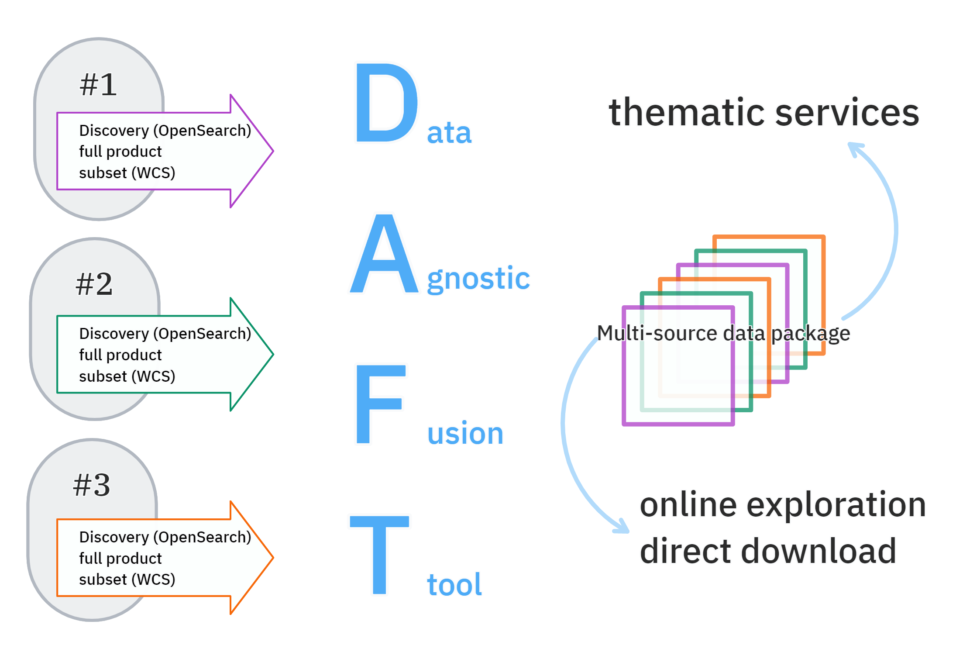
Figure 1. Data Agnostic Fusion Tool (DAFT)

On the left side, various input data sources are depicted, assuming they offer OGC-compliant data discovery and access services. These services enable the identification of products to be packaged, access to the complete original products, and the ability to perform on-the-fly subsetting for faster packaging. The DAFT module itself harmonizes the incoming data both spatially and temporally, resulting in a fused product. The data package generated from multiple sources forms the foundation for delivering thematic services. The data package can be downloaded directly for further utilization. DAFT comprises an asynchronous API that can be activated from diverse platforms. When a DAFT query is executed, it generates a JSON file as the output, which includes a download link for the merged data product(s).
To demonstrate the progress and effectiveness of the project's development, three specific scenarios were chosen for showcasing purposes. These scenarios focus on aviation, greenhouse gas emissions from fires, and biomass change, respectively. Due to the unavailability of GEDI and ICESAT2 data on the MAAP platform, it was not possible to implement the third scenario, which would have elaborated the change of biomass using various input data.

The development of DAFT presented several challenges due to various factors. Firstly, there were difficulties in data preparation, indexing, and delivery. The sheer volume of data, along with the need to organize and structure it efficiently, posed significant challenges for the development team. Additionally, the heterogeneity of the data added another layer of complexity. Different data sources and formats had to be integrated and harmonized within DAFT, requiring attention to ensure interoperability and consistency across the system. Furthermore, the project encountered constraints related to operating systems, particularly concerning the ESA PDGS (Payload Data Ground Segment). Adhering to these constraints and ensuring compatibility with different OS environments presented additional technical hurdles.

Scenario I – Aviation
The first scenario focuses on the aviation sector and aims to provide calculations of air pollution levels along flight paths, as well as the overall exposure to air pollution. Additionally, in the event of critical air pollution levels being exceeded, optimized flight paths are generated. The workflow of the second scenario is depicted in Figure 2.

To achieve this, input data including CAMS and WRF-Chem data on flight levels for SO2 and aerosols, along with flight tracks, are utilized by the NAVSIM software. NAVSIM calculates air pollution levels along flight paths, total exposure, and optimized flight paths based on this input. To validate the model output of NAVSIM, DAFT is employed to harmonize and compare total column data of SO2 and aerosols from CAMS and WRF-Chem with observations of the same parameters obtained from TROPOMI, IASI, and MODIS.

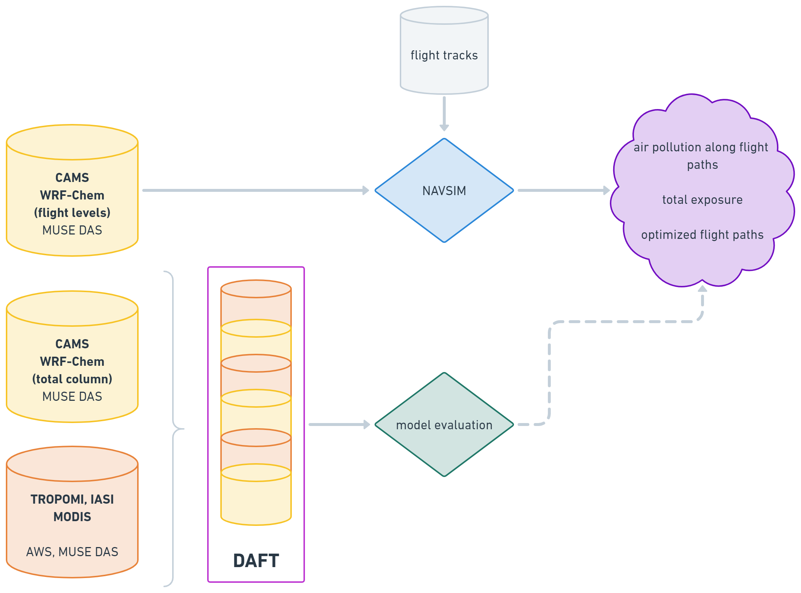
Figure 2. Scenario I workflow

Scenario II – Fires
The second scenario focuses on global fires and aims to achieve multiple objectives, including identifying potential fire locations, forecasting fire evolution and spread, and calculating emissions and fluxes resulting from the fires. The workflow and implementation of DAFT within this scenario are depicted in Figure 3.
To begin, data extracted from existing repositories are passed through DAFT, which harmonizes the data to match the required spatial scale and extent for further analysis by the wildfire climate impacts and adaptation model (FLAM). FLAM models the spatial progression of detected fires and generates output in the form of forecasted burned areas. These forecasted burned areas serve as input for the WRF-Chem model, which models the cycle and evolution of greenhouse gases (GHG).
If the two model runs have different spatial resolutions, DAFT is employed to homogenize the output of the two models, as illustrated by the dashed rectangle in Figure 3. Sentinel-5p TROPOMI data can be utilized for verification purposes within this scenario.

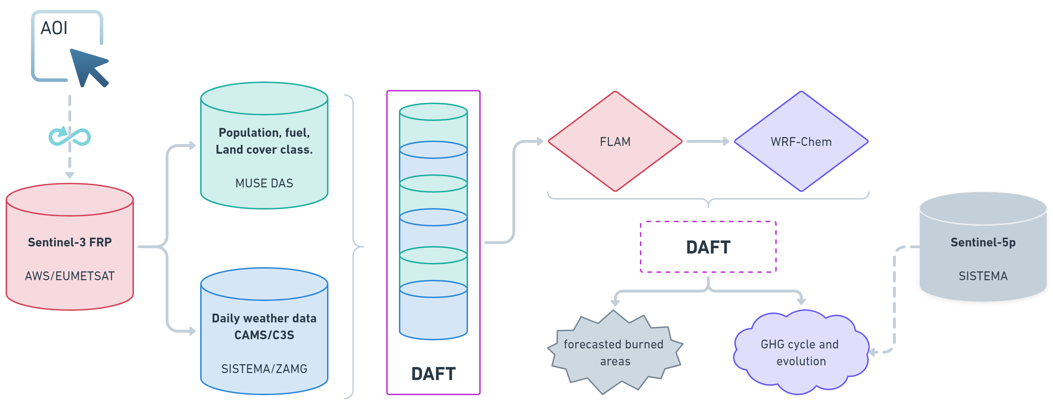
Figure 3. Scenario II workflow

Scenario III – Biomass
Scenario three aims at assessing biomass layer changes at regional/continental level, fusing observational data with in-situ measurements, which allows obtaining periodic global accounting of the biomass amount and fluxes.

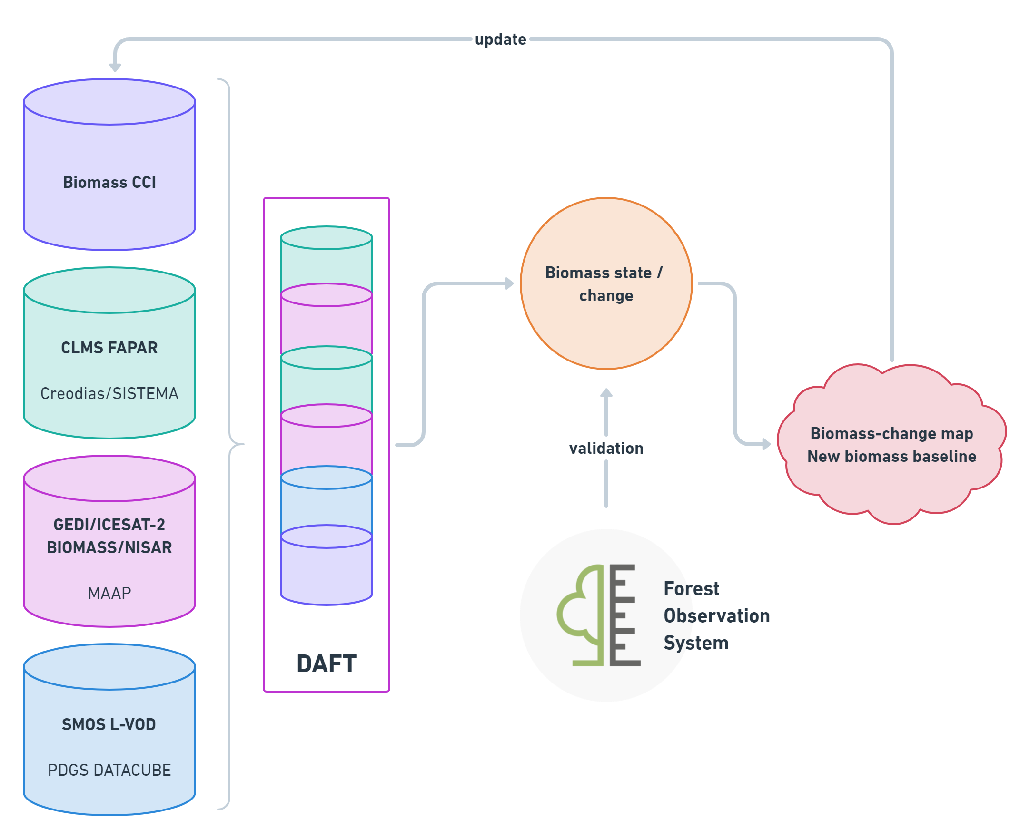
Figure 4. Scenario III workflow

To produce periodic maps of biomass change, a variety of satellite data including GEDI, ICESAT-2, BIOMASS, and Copernicus vegetation information are merged. The baseline for assessing biomass will be the ESA CCI Biomass project data. By utilizing the capabilities of the GEDI and ICESAT-2 sensors, biomass status and changes can be monitored on a regional, country, and even continental scale every few months. As soon as BIOMASS and NISAR products become available through MAAP, the service will incorporate them into the existing data to improve the accuracy of the results.
Unfortunately, near real-time data (GEDI and ICESAT2) that were supposed to be accessed via the MAAP platform, were not available during the project timeline thus the use case has not been implemented.

Project Results
Scenario I focused on assessing the impact of air pollution on aviation by utilizing diverse data sources, including remote sensing observations and model output. The air traffic simulator NAVSIM played a crucial role in calculating air pollution levels along flight paths and overall exposure. To achieve this, NAVSIM incorporated data from CAMS and WRF-Chem models at flight levels, as well as information on European and global flight tracks. In cases where critical air pollution thresholds were anticipated, NAVSIM generated optimized flight paths to minimize the adverse effects of aerosols and SO2 on aircraft and engines. To ensure the reliability of the model's outcomes, the CAMS and WRF-Chem model output underwent validation using satellite instrument data from TROPOMI, MODIS, and IASI. This validation process helped to enhance understanding of the accuracy and validity of the model's predictions.
In investigating the impact of air pollution on aviation, the CAMS and WRF-Chem model output underwent initial validation using observational satellite data through the DAFT system. Temporal means were derived from various Earth observation measurements and model output using DAFT, followed by data visualization and analysis for discrepancies. However, conducting an in-depth investigation into the disparities between satellite measurements and the model simulation was beyond the project's scope.
Validation of the models for SO2 proved challenging due to inconsistent patterns observed in SO2 fields from satellite observations. The reasons behind these implausible SO2 concentrations from satellite measurements remain unknown and require further investigation.
Both the CAMS and WRF-Chem models underestimated the magnitude of the fire plume generated by the reference wildfires compared to the Aerosol Optical Depth (AOD) captured by MODIS. This suggests that additional refinement of model parameters is necessary to accurately represent events of such scale. However, there was overall agreement among all data sources regarding the trajectories of the plume.
The scientific findings also revealed that while the WRF-Chem model effectively reproduced the location of wildfires and the dispersion of the plume, the parameterization of sea salt in the model was deemed inadequate.

Globally, wildfires are escalating in frequency and severity due to climate change, including within the European Union where efforts to mitigate the impact have proven insufficient. These fires not only cause property damage and loss of life but also emit pollutants that pose health risks and impact the aviation industry, exacerbating climate change. In Scenario II, a historic fire in Sardinia in July 2021 was analyzed using the FLAM and WRF-CHEM models. FLAM determined the fire's location, spread, and burned area, estimating carbon emissions through combustion completeness calculations. The calibrated FLAM output was validated using satellite data from DAFT, while the WRF-CHEM output was validated with atmospheric data from Sentinel-5p. To ensure accurate estimates, FLAM underwent calibration based on historical remote sensing data and current biomass, land cover, and population density information. Without calibration, FLAM underestimated the burned area, leading to adjustments in key parameters. After calibration, FLAM demonstrated improved alignment with the actual burned area, indicating enhanced accuracy in estimating fire extent.

Conclusions And Future Perspectives
The MUSE project enabled the development and demonstration of the DAFT module, an efficient tool for generating geospatial data packages. The implementation of various scenarios has provided valuable insights and feedback, highlighting the versatility and potential of the DAFT module for a wide range of applications. The successful utilization of the module in these scenarios opens up opportunities for its application in numerous follow-on activities. The feedback collected from the project consortium further enhances the refinement and optimization of the DAFT module, ensuring its adaptability and effectiveness in addressing diverse data-related challenges.

Several planned improvements are underway for the DAFT system. One of the key enhancements is the ability to programmatically set the origin of the common grid and the bounding box, allowing for greater flexibility and customization. Additionally, there are plans to include a quality mask or layer that will provide valuable information about the reliability and accuracy of the data. Another focus area is to improve the stability and scalability of the DAFT system, ensuring its robustness and ability to handle increasing volumes of data. Furthermore, efforts are being made to incorporate a comprehensive list of available collections, making it easier for users to reference and access the desired datasets. These improvements will enhance the functionality and usability of the DAFT system, providing researchers and users with a more efficient and reliable tool for accessing and analyzing data.

The successful implementation and demonstrated capabilities of the DAFT module in the MUSE project have paved the way for its potential application in future projects. Projects such as AIRPLAN, MAAP/BREATHE, EO4EU, and IDEAS can benefit from the utilization of DAFT, leveraging its data harmonization and packaging functionalities. Recognizing the potential of DAFT, there are plans to integrate it as a native functionality of the ADAM platform, enabling seamless data preparation and indexing within the platform itself. Additionally, a DAFT Python package is planned, allowing for easier integration and utilization of DAFT's features in various workflows and projects. Finally, the deployment of DAFT at ESA PDGS is an option, which shall be evaluated. The expansion and integration of DAFT into these projects and platforms signify its potential growing significance in facilitating efficient and reliable handling of geospatial data.

Dissemination And Outreach

Event | Date(s) | Type
GSTP ESA Industry Day, Vienna | 2022-06-22 | Presentation
EU Space Week 2022, Prague | 2022-10-05 | Presentation
Il programma Copernicus.  I servizi europei per la gestione del territorio, Bologna | 2023-02-08 | Presentation

