|  |
| --- |
| **Development of TTEthernet Equipment for Lunar Orbital Platform Gateway**  Contract No. 4000126290/18/NL/BJ/va  Executive Summary Report |

|  |  |
| --- | --- |
|  |  |
| **Author:** | David Jelem |
| **Reference:** |  |
| **Security:** | Confidential |
| **Document number:** | D-TT-EPOS-TN-03-003 |
| **Version:** | 1.0 |
| **Date:** | 2019-09-17 |
| **Status:** | Draft release |
| **Review:** |  |
|  |  |

Revision Chart

A revision is a new edition of the document and affects all sections of this document.

|  |  |  |  |
| --- | --- | --- | --- |
| Version | Date | Responsible Person | Modification |
| 1.0 | 2019-09-17 | David Jelem | Initial Release |
|  |  |  |  |

Contents

[1 Introduction & Product Concept 3](#_Toc19618683)

[1.1 TTE-End System Space cPCI 4](#_Toc19618684)

[1.2 TTE-Switch Space cPCI 4](#_Toc19618685)

[1.3 TTE-Avionics Hosting Unit 5](#_Toc19618686)

[2 Form factor & connector study 5](#_Toc19618687)

[2.1.1 Form factors 6](#_Toc19618688)

[2.1.2 Trade-off between modular concept and custom box 7](#_Toc19618689)

[3 De-risking of Critical Components 8](#_Toc19618690)

[4 System Architecture Study - Aligned Requirements 9](#_Toc19618691)

[4.1 End System Features 9](#_Toc19618692)

[4.2 Switch Features 9](#_Toc19618693)

[4.3 Avionics Hosting Unit 10](#_Toc19618694)

[5 Summary & Conclusion 10](#_Toc19618695)

# Introduction & Product Concept

TTTech has in the past provided its deterministic Ethernet IP (TTEthernet) to the Orion Spacecraft and the TTE Controller ASIC to the Ariane 6 Program, and an ECSS Standard for the protocol is in preparation. NASA and ESA have identified TTE as future avionics technology for human space exploration. A preliminary activity was required to confirm the feasibility of a European TTEthernet Equipment for the Gateway Space Station. The objective of this activity was to investigate the technical feasibility and optimal form-factor of TTEthernet Equipment for the Gateway and identify & assess major technical risks for such a development. The results of this de-risking study are then proposed to be used as input to the follow-on project that will develop the actual flight equipment. The activity was split into three main work packages:

* Conceptual design
* Critical components de-risking
* Architecture assessment with primes

This executive summary reports the major outcomes of the activity.

The Time-Triggered Ethernet Platform for Outer Space (TT-EPOS) is a modular spacecraft avionics network concept based on TTEthernet and designed for manned and unmanned space exploration missions. To allow for maximum compatibility with heritage avionic platforms, both basic network building blocks (Switch and End System) will be based on the compact and standardized form factor 3U cPCI which can be integrated into the TTE-Avionics Hosting Unit. The TTE-Avionics Hosting Unit (TTE-AHU) allows mounting up to four 3U cPCI cards, connected via a shared cPCI backplane. The enclosure features a DC/DC power supply that safely transforms spacecraft bus voltage of 98-136V (ISPSIS, Draft C) to standard cPCI supply voltages (PICMG 2.0 R3.0). Connectors can be adapted to specific use cases via a modular front panel. The TTE-Avionics Hosting Unit supports the setup and definition of customer specific functional blocks (e.g. flight computers, remote terminal units, etc.) by means of the modular building blocks by combining the TTE-End System Space cPCI and TTE-Switch Space cPCI. The TT-EPOS End System and Switch will both be provided in a 3U cPCI form factor.

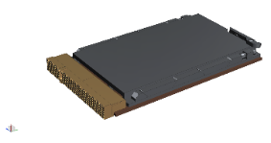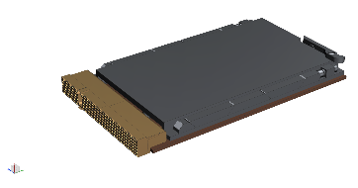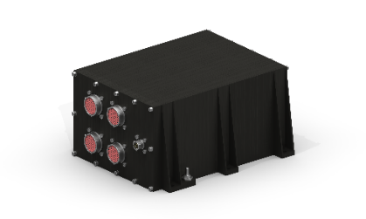 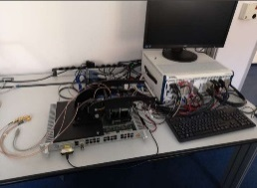

Figure 2: TT-EPOS Product Tree

In addition to the items shown in the product tree, there are also two supporting items which are also recommended for the use of TTEthernet products:

* TTE-Driver (A software application interface for TTEthernet access on a host computer)
* TTE-Configuration Tools (Network configuration tools to configure TTE-traffic)

## TTE-End System Space cPCI

The TTE-End System Space cPCI connects the user data-processing hardware (microprocessors, CPUs, FPGAs) to the TTEthernet network. It comes as a cPCI 3U form factor and permits the integration of synchronized and non-synchronized functions in Ethernet-based distributed systems. It features 3 Ethernet ports, full-duplex at up to 1Gbps, which are routed to the cPCI backplane, together with the host interfaces PCI, (Q)SPI and SpaceWire. While hard real-time functions enjoy reserved bandwidth, full determinism and delivery jitter below 1μs using SAE AS6802 time-triggered traffic, ARINC 664 part 7 and standard IEEE 802.3 Ethernet traffic operates without impact on time-critical and synchronized functions. The TTE-End System Space cPCI provides support for fault-tolerant, high-speed data communication in a single device. The TTE-End System Space is qualified to the specified environmental loads according ECSS standards. The TTE-End System Space cPCI provides an integrated Leon2 management CPU allowing the chip to provide data loading and diagnostic functions. The CPU runs with 125MHz and can be accessed over external interfaces (DSU) for extended diagnostics functionality. The TTE-End System Space cPCI consumes 6 W of power and weighs 0.4 kg.

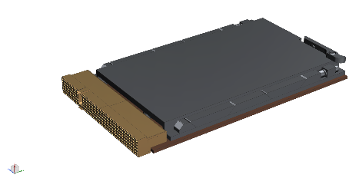

Figure 5: TTE-End System Space cPCI.

The unit is built as a 32bit PCI peripheral unit according to the CompactPCI® Specification [RD-3] featuring both J1 and J2 connectors. Therefore, the unit can be integrated in a standard CompactPCI peripheral slot, which defines the connectivity for power, JTAG and data via PCI on connector J1. Unit specific signals are routed exclusively on J2 for further functionality as well as connectivity to all ethernet ports of the end-system.

## TTE-Switch Space cPCI

The TTE-Switch Space cPCI is a TTEthernet switch in a 3U cPCI form factor as illustrated below (RD1, RD2). This card offers a switching capability of 6x 100/1000Base-T Ethernet ports and 6x 100Base-TX Ethernet ports. It supports the three TTEthernet traffic classes: Best-effort traffic (IEEE 802.3), Rate-constrained traffic (A664 part 7) and Time-Triggered traffic (SAE AS6802, as described in RD4.

The TTE-Switch Space supports an internal on-chip COM/MON within the same TTE-Controller ASIC (dual-core lockstep). This safety features ensures the fail-silent behavior of the switch and therefore allows to create single-fault tolerant architectures with two channels. The COM/MON functionality can also be used to perform bitwise comparison of data streams from processors to create high integrity data that will become fail-silent as soon as there is a disagreement. The switch supports management function comprising of Simple Network Management Protocol (SNMP) for health monitoring and status, Trivial File Transfer Protocol (TFTP) for data loading and built-in self-test mechanisms. Test interfaces (Debug Support Unit & SpaceWire) allow accessing the internal management CPU (internal to the TTE-Controller Switch Space) for debugging & testing. The TTE-Switch Space cPCI consumes 14 W of power and weighs 0.6 kg.

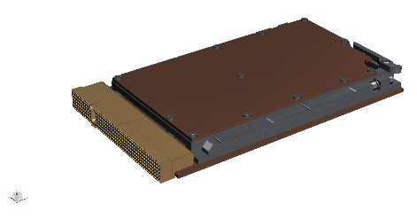

Figure 4: TTE-Switch Space cPCI

## TTE-Avionics Hosting Unit

The TTE-Switch Space Enclosure (LRU) that allows mounting up to four 3U cPCI cards, connected to a shared backplane. The TTE-Switch Space can be attached to any available surface, via 6 M5 bolts. For a standalone TTEthernet Switch (LRU), the TTE-Switch Space Enclosure can be combined with one or two TTE-Switch Space cPCI cards to form a 12 or 24 port Switch unit. The connector panel on the rear side of the enclosure allows a flexible adaptation of the interface connector type.

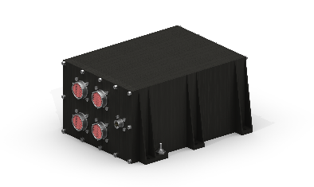

Figure 6: TTE-Avionics Hosting Unit

# Form factor & connector study

TTTech was studying conceptual designs for a TTEthernet End-System (ES) and Switch (SW) platform for space. These designs will rely on the so-called SpaceASIC (TT6802) developed by TTTech for the core functions.

The studied form factors and product solutions are investigated for their suitability in terms of:

1. **Real-Estate:** How much functionality can be provided on the provided real-estate
2. **Connectivity:** How much functionality can be provided given the connector interface and backplane standards
3. **Applicability:** How easily can the form factor be integrated and applied in a bigger architecture (e.g. connection to a computer as host).

### Form factors

The following table summarizes the previous sections and highlights the most suitable candidate of 3U systems (as according to the previously described development strategy starting with a 6U system does not make much sense), which covers most use-cases for TTEthernet end-systems as well as TTEthernet switches and provides the greatest compatibility with already existing systems.

|  |  |  |  |  |
| --- | --- | --- | --- | --- |
|  | PMC | cPCI | VPX | cPCI serial |
| Outline |  |  |  |  |
| PCI spec | YES (PMC) | YES (cPCI) | YES (SpaceVPX)[[1]](#footnote-1) | NO |
| SpW spec | NO (but available on P4) | NO (but available on J2) | Yes (SpaceVPX – control plane) | YES (cPCI serial space)[[2]](#footnote-2) |
| Eth spec | NO (but available on P4) | NO (but available on J2) | NO (not part of SLT3-PER-1Q2T-14.3.2 but available on P1) | YES (8x 1000Base-T with cPCI serial, further ports available on P3) |
| ES Use-Case | Not enough board space | PCI+(SpW)+ 3x1000Base-T | (PCI)+SpW+ 3x1000Base-T | SpW+ 3x1000Base-T |
| SW Use-Case | Not enough board space | 6x1000Base-T 6x100Base-TX | 6x1000Base-T | 6x1000Base-T >=6x100Base-TX |
| Compati-bility | cPCI/VPX/cPCI serial carrier | cPCI backplane cPCI plus IO backplane cPCI serial hybrid bp. SpaceVPX hybrid bp. | SpaceVPX custom bp. | cPCI serial custom bp. |
| Supply rails | +3.3V/+5V/+12V/-12V | +3.3V/+5V/+12V/-12V | +3.3V/+5V/+12V | +12V |
| Cond. cooled slot dim. | N/A | 103x13.335mm | 103x13.335mm | 120x14.4mm |
| Cond. Cooled slot/slot distance | N/A | 20.32mm | 20.32mm | 25.4mm |

cPCI is favored due to its compatibility with other standards, and its wide range of available off-the-shelf hardware which can be used to build lab and engineering models.

### Trade-off between modular concept and custom box

|  |  |  |
| --- | --- | --- |
|  | cPCI Box | Custom Box |
| Outline |  | C:\Users\jelem\Pictures\Space_BDB.PNG |
| PCI spec | YES (cPCI) | NO |
| Number of slots | 4 (1x System, 3x Peripheral) + DC/DC converter | N/A |
| ES Use-Case | YES | NO |
| SW Use-Case | 1 slot: 6x1000Base-T + 6x100Base-TX 2 slots: 12x1000Base-T + 12x100Base-TX | 6x1000Base-T 18x100Base-TX |
| Compati-bility | cPCI, conduction cooled | NO (proprietary design) |
| Flexibility | Customer can add cPCI conduction cooled cards | NO |
| Mass | Depends on customer specific configuration  (24port TTE Switch: 5kg) | 3.2kg |
| Power consump-tion | Depends on customer specific configuration  (24 port TTE Switch: 25W typ., 35W max.) | 19.9W typ.  27.8W max. |
| Primary power bus | 120V (28V option) | 120V (28V option) |
| Cond. cooled slot dim. | 103x13.335mm | N/A |
| Cond. Cooled slot/slot distance | 20.32mm | N/A |
| Qualification risk | Medium, no heritage | Low ,similar boxes successfully qualified |

cPCI box is favored due to its inter-compatibility with other standards, and its wide range of available off-the-shelf hardware which can be used to build lab and engineering models.

The selected approach allows for a modular front panel plate and thus an easy exchange of the connector types.

# De-risking of Critical Components

During this study the TTE-Controller radiation test results from the Ariane 6 program were assessed for the Gateway use case. The susceptibility to functional upsets due to radiation effects and effects of total doe were assessed. Beside the TTE-Controller also all other parts have been assessed. Each part type which is planned to be used in the TTE ES and TTE SW design is checked for risks with respect to:

* Schedule
* Quality
* Mounting

Several component risks have been identified, and de-risking measures have been proposed. The following technical risks have been found to be the most relevant:

|  |  |  |  |  |  |
| --- | --- | --- | --- | --- | --- |
| **Component** | **Manufacturer** | **Risk Schedule** | **Risk Quality** | **Risk Mounting** | **Mitigation** |
| Connector | Mezalok | medium | low | high | Mounting evaluation is planned at RSA |
| Ferrites | AEM | low | low | high | RSA proposes to replace the HRB types by Coilcraft AR425PJB series parts. |
| EthernetTransceiver (PHY) | Microchip | High  (+single source) | medium | low | Evaluation of alternative solutions (e.g. upscreening of commercial type VSC8541XMV-05) is ongoing. - Intensified negotiations with Microchip by TTTech/RUAG - NASA was made aware of single supplier situation and possible monopoly (this risk is applicable for the entire Gateway) - ESA also took the action to address this issue with NASA (see MoMs of Conceptual Design Review) |
| TTE-Controller (Qualified ceramic package) |  | high | low | low | - metal layer fix applied instead of silicon re-spin - start of qualification immediately thereafter (need go-ahead from ESA) |

# System Architecture Study - Aligned Requirements

As part of this study, system requirements have been aligned between US customers, TTTech’s proposed product concept and the European primes Thales Alenia Space and Airbus Defense & Space. The in the following presented set of features has been developed to have found broad acceptance in the industry.

## End System Features

|  |  |
| --- | --- |
|  | **TTTech Proposal** |
| ES-01 | Protocol: TTEthernet (Best Effort, Rate Constrained , Time-Triggered) |
| ES-02 | Network and Transport level protocol: support for IP/UDP for TT, RC and BE traffic |
| ES-03 | Radiation Environment: GEO |
| ES-04 | Lifetime: 15 years |
| ES-05 | Redundancy: End System can be connected to 3 TTE Network planes |
| ES-06 | 3U cPCI form factor (PICMG 2.0 R3), conduction-cooled (ANSI/VITA 30.1-2008) |
| ES-07 | 3x Ethernet Ports (3x 1000BaseT or 3x 100BaseTX) |
| ES-08 | PCI, SPI & SpW host interfaces |
| ES-09 | DSU debug I/F |
| ES-10 | Operating Voltage: 3.3 V |
| ES-11 | Power: 6W |
| ES-12 | Mass: 0.4 kg |
| ES-13 | IOs: All signals to backplane |
| ES-14 | Temperature I/F range: -35 to +72 degC |
| ES-15 | Replaceability: Card replacement possible |
| ES-16 | Process: Tailored ECSS (to be negotiated) |

## Switch Features

|  |  |
| --- | --- |
|  | **TTTech Proposal** |
| SW-01 | Protocol: TTEthernet (Best Effort, Rate Constrained , Time-Triggered) |
| SW-02 | Network and Transport level protocol: support for UDP for TT, RC traffic |
| SW-03 | Radiation Environment: GEO |
| SW-04 | Lifetime: 15 years |
| SW-06 | Redundancy: Redundant traffic processing in COM/MON |
| SW-07 | 3U cPCI form factor (PICMG 2.0 R3), conduction-cooled (ANSI/VITA 30.1-2008) |
| SW-08 | 12x Ethernet Ports (6x 1000BaseT, 6x 100BaseTX) |
| SW-09 | DSU debug I/F |
| SW-10 | Operating Voltage: 3.3 V |
| SW-11 | Power: 14W |
| SW-12 | Mass: 0.4 kg |
| SW-13 | IOs: All signals to backplane |
| SW-14 | Temperature I/F range: -35 to +72 degC |
| SW-15 | Compatible with pressurised and unpressurised environments |
| SW-16 | Replaceability: Card replacement possible |
| SW-17 | Switch Firmware & config updates during mission |
| SW-18 | Process: Tailored ECSS (to be negotiated) |

## Avionics Hosting Unit

|  |  |
| --- | --- |
|  | **TTTech Proposal** |
| AHU-01 | Primary Voltage: International Power Interoperability Standard compliant (120V) |
| AHU-02 | Backplane Voltages |
| AHU-03 | Replaceable connector plate |
| AHU-04 | 4 3U cPCI slots for 3U cPCI form factor (PICMG 2.0 R3), conduction-cooled (ANSI/VITA 30.1-2008) |
| AHU-05 | Supports in-orbit replaceability of cards |
| AHU-06 | 75W total power for host cards |
| AHU-07 | Mass: 5.85 kg |
| AHU-08 | 5 mm of shielding to hosted units |
| AHU-09 | MIL-DTL-38999 Connectors for Ethernet (but can be exchanged upon request) |
| AHU-10 | Process: ECSS (tailoring to be negotiated) |

# Summary & Conclusion

TTTech Computertechnik AG and RUAG Space Austria have jointly investigated several possible architectures of TTEthernet equipment for the Gateway. Once a concept design was created, the crucial elements and risks of this design were assessed.

The outcome of the activity was a conceptual design that has been assessed feasible and can be implemented in a follow-up activity. The design proposes a common form factor (3U cPCI) for the Switches and End Systems, an industry standard that is accepted/adopted by many customers worldwide and provides a high degree of interoperability with heritage systems. A competitive networking product concept has been developed, that has received very positive feedback form space industry and can, due to its modularity, fit into various customer architectures and concepts.

The maturation of the concept design towards a Breadboard, Qualification and Flight is planned in a follow-up GSTP activity until 2022. The equipment is foreseen to be used by European prime contractors in the international Habitat (iHAB) as part of the Gateway.

1. Only defined for a system slot, not defined for our use case [↑](#footnote-ref-1)
2. cPCI serial space would require a redundant SpW interface, however, we could only offer a single interface [↑](#footnote-ref-2)