Website page
High performance cooling methods are necessary to meet the thermal challenges associated with the ongoing miniaturisation of electronic devices for satellites. Conventional passive devices such as heat pipes are no longer capable of managing the expected power densities, and ESA have turned to actively pumped two phase cooling loops. The pumps for these applications must withstand high working pressures (up to 60 atmospheres) and meet stringent requirements for reliability.
The researchers at the University of Limerick (UL) have developed a unique micropumping technology that allows for high pumping powers, high reliability, and high working pressures.
As part of an OSIP project, the UL team developed a flow control unit consisting of manifold of five micropumps and a flow sensor that can withstand high working pressures (up to 150 bar). The flow control unit was integrated into a two-phase cooling demonstrator using Novec 7100 as working fluid and it was shown that with a flow rate of 124 g/min it was possible to dissipate a heat rate of 350 W (16.5 W/cm²).

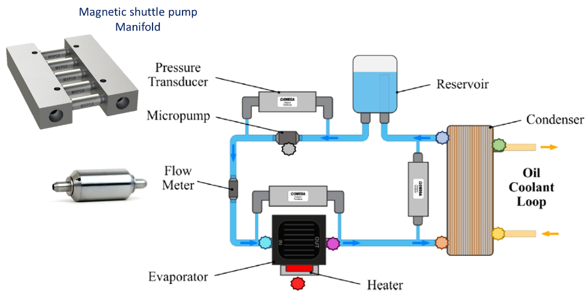
Figure 1 - Schematic of the 2-phase cooling loop

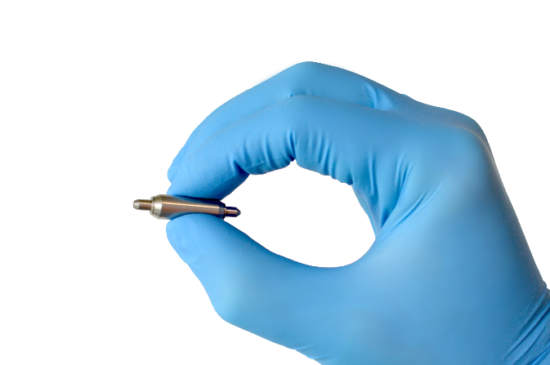
Figure 2 - Scale of the micropumps used

