TEch4EO
Executive summary report

ESA Contract: 4000138668/22/NL/GLC/zk
Framework: GSTP
Document No.: GSAT-PRJ-T4EO-ESR-01
December 2023

CONTENTS
1. Context 3
3. Technical objectives and structure of TECH4EO project 3
4. Activities and Results 4
5. Conclusions 6
6. Next Steps 6

ACRONYMS AND ABBREVIATIONS
AoI Area of Interest
API Application Programming Interfaces
EO Earth Observation
GRD Ground Resolved Distance
VHR Very High Resolution
VNIR Visual (Red, Green and Blue) and Near InfraRed bands

Contact
Marina Carballo, Sat Ops Senior Engineer

This document summarizes the work performed in Tech4EO, including a brief overview of results and conclusions. It is not intended to be an exhaustive presentation of the results.

1. Context
GEOSAT is one of two fully European optical EO VHR Satellite operators, providing imagery and data products to both the institutional and commercial markets.
Currently operating GEOSAT 1 wide swath satellite and GEOSAT 2 very high-resolution satellite, GEOSAT intended to deploy a new satellite constellation, with improved resolution, revisit and allowing to maintain the end-to-end agility that is critical to its activity.
TECH4EO is a study aimed at the VHR component of GEOSAT’s future constellation, from within ESA's General Support Technology Program (GSTP), to focus on the comprehensive development of the technological components of a next generation constellation, as well as mapping opportunities to foster local capabilities in Portugal that can add value and complementarity to the ones existing in Europe, while benefitting from ESA’s guidance to ensure robust EO technology development.

3. Technical objectives and structure of TECH4EO project
The objectives of the study are related to the development of:
- Mission statement, objectives, requirements and assumptions.
- Concepts for system architecture and their elements.
- Programmatic elements such as development approach and schedule or ROM cost estimates.
- Identification of critical technologies and required development activities.
- Risk assessment and mitigation plan.

TECH4EO’s Work Breakdown Structure is the following:

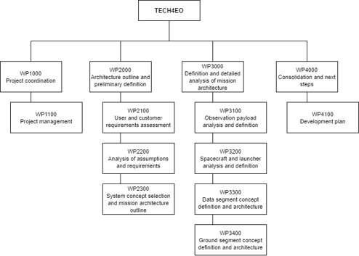

4. Activities and Results
TECH4EO delineates a set of work topics within four major work-lines to establish a complete next-generation EO system:
- Mission: consolidation of user needs and related mission requirements, concepts, configurations and orbits.
- Space Segment: definition of the architecture of the VHR satellite and specification of elements for platform and payload subsystems.
- Ground Segment: definition of mission control centre concept and design of a distributed cloud-based control centre, to support a transition from the operation of existing EO assets to the new VHR constellation.
- Data Segment: concept for a distributed Data Hub for the collection, management, processing, and distribution of constellation data, both open and commercial. The activities include the design of the Data hub architecture and data management, archiving and processing chains, the definition of specifications for automated processing chains for existing assets and, the definition of Application Programming Interfaces (APIs) for different user segments and for interoperability with different customer systems and platforms.
The results of the TECH4EO project study include:
- Analysis of the EO market and the competitive landscape, to define the user needs associated with different market segments.
- Translation of user needs in user requirements. Priority markets are identified in light grey. From this analysis, the main target markets identified were:
  - Land Mapping
  - Infrastructure monitoring
  - Security and Emergency
  - Oil and gas
  - Maritime
To address these markets, resolution needs to be between 0,3 and 0,5m, with some application allowing for resolution of 1m; revisit should be at least daily; latency ranging from applications in which near / quasi real time capabilities are needed to others that have no specific requirements. Spectral bands, beyond the VNIR, benefit from including Red Edge bands.
- Products and services characterization.
- End to end mission objectives and requirements.
- Mission design study.
- Preliminary system and subsystem design.
- Trade-off between make or buy options and Business implications.
- High-level benefit-cost analysis with risk assessment.
The general mission concept is the following:
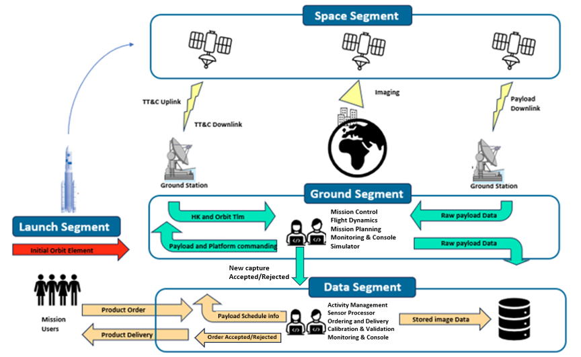

5. Conclusions
TECH4EO lays the work for a specific mission, emphasizing collaboration, innovation, and the integration of building blocks. The proposed activities align with ESA's strategic goals, positioning TECH4EO as a key contributor to the evolving European and international EO landscape.
The main conclusions derived from the Tech4EO study are:
- A relevant solution in the VHR market segment requires a resolution (defined through GRD, Ground Resolved Distance) equal or better than 0,5m; at least daily revisit and a near-real-time latency (satellite to user’s laptop). Some of the traditional markets (e.g. agriculture) can be approached with some relaxation on these requirements as long as they can provide for a coherent analysis (e.g. comparable acquisition conditions).
- Desired payload and platform requirements to address customer needs and provide for adaptability to market trends were defined using as reference COTS and available solutions. User experience; expedite processing and analysis, as well as timely delivery of imagery and data, are key in developing and integrating ground and space segment subsystems.
- Analysis of different configurations and orbital planes led to the selection of three satellites in SSO with 97.4º inclination at mean 500km altitude.
- Accelerating operationality and robustness of the new constellation requires to go for the “buy” option in the make vs. buy dilemma when it comes to critical subsystems, such as payload or ADCS.
- Risk assessment for LEO constellations needs to balance between the need of simplifying qualification processes, to allow for cost reduction, and maintaining overall performance and reliability that Space missions need. Nevertheless, performance and availability can be managed at constellation level, as opposed to having a satellite as a mission’s single point of failure.

6. Next Steps
The TECH4EO study allowed to tackle many of the challenges involved in deploying a next generation agile and effective EO constellation. At the same time, it unravelled new challenges and needs to delve deeper in some of the analysis, namely related with revisit vs. swath and satellite agility; long-term orbital analysis, considering manoeuvres and controlled re-entry at end-of-life; and the impact of focusing over specific regions of interest.
Future work will focus on these items, together with analysis of innovation within specific subsystems, and the operational integration of this constellation with the Portuguese component constellation, under GEOSAT’s responsibility.

Formerly known as Deimos-1
Formerly known as Deimos-2

